**NORTH BENNET STREET SCHOOL CONSERVATION TREATMENT REPORT**

**Prepared by** Sarah Kim **Date** September 9, 2017

**Report number** 2017.0909

**Call number** N/A

**Author** Thomas W. Knox

**Title** The Boy Travellers in the Far East: Adventures of Two Youths in a Journey to Japan and   
 China

**Place of Publication** New York (Harper & Brothers, Publishers | Franklin Square)

**Date of Publication** 1880 **Acc. No. barcode #** N/A

**CONDITION**

**Binding**

Red book cloth full tight-back binding. Stamped gold and black Asian decorative elements on boards and spine. Both boards completely detached; boards showing areas of abrasion; worn edges on all four corners. Spine piece detaching from front board joint, exposing brittle paper lining and mull lining. Missing spine pieces on head and tail. Textblock completely split at the center.

**Text paper**

Off-white paper in fairly good condition, slight browning on the fore edges.

**Endpapers**

Olive colored paper with black illustrations of Asian women and men holding umbrellas, wearing hats, holding fans and cymbals, etc., potted flowers, dragons and other mythical creatures, etc.

**Sewing**

Five sawn-in sewing stations.

**Forwarding**

Damaged and fraying red and white striped endbands, missing cords.

**TREATMENT**

**Spot tests**

N/A

**Paper repairs**

N/A

**Forwarding treatment**

The boards, spine, edges of text block, and end papers were surfaced cleaned with Gonzo sponge.

**Binding repair**

Surfaced cleaned the boards and textblock with a soft-bristle brush, then with gonzo sponge, and with makeup sponge on edges of textblock. Removed old paper lining, mull, and old glue mechanically then using the poultice method (4% SCMC solution). Disbinded and guarded few signatures with Kozo white Japanese tissue. Rebound the textblock using its original sewing stations and replaced old cords with new twine. Replaced old headbands new red striped headbands made with muslin and red Sharpie (for the lines). Put muslin spine lining. Cut up frayed cloth on detached boards so edges are smooth. Used wheat paste to repair the laminating corners. Toned Kozo white Japanese tissue with Golden acrylic paint to color match original book cloth. Reattached boards with PVA to toned cloth with 10pt board spine lining by lifting original cloth on outside hinges of boards. Cased in textblock with PVA by lifting original paste paper on the hinges. Toned Kozo white Japanese tissue to color match the inner hinges and attached with PVA. Toned Kozo white Japanese tissue to color match to original book cloth to patch up exposed corners. Used MC and acrylic paint to touch up the whitened edges of the book cloth. Trimmed original spine and reattached with PVA.

**Protective housing** Black book cloth clamshell box, with paper gold foil stamped label on spine.

**Photographic record**

Before:

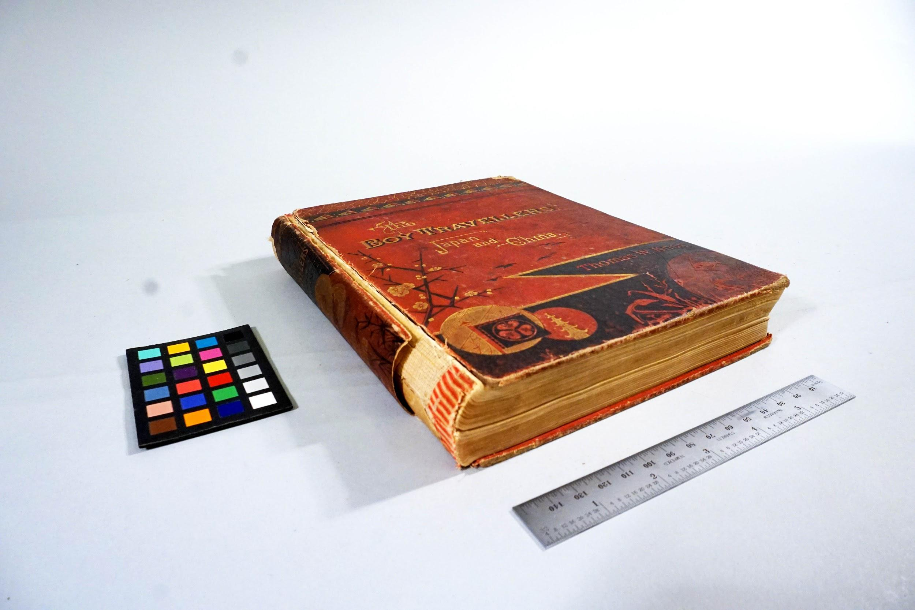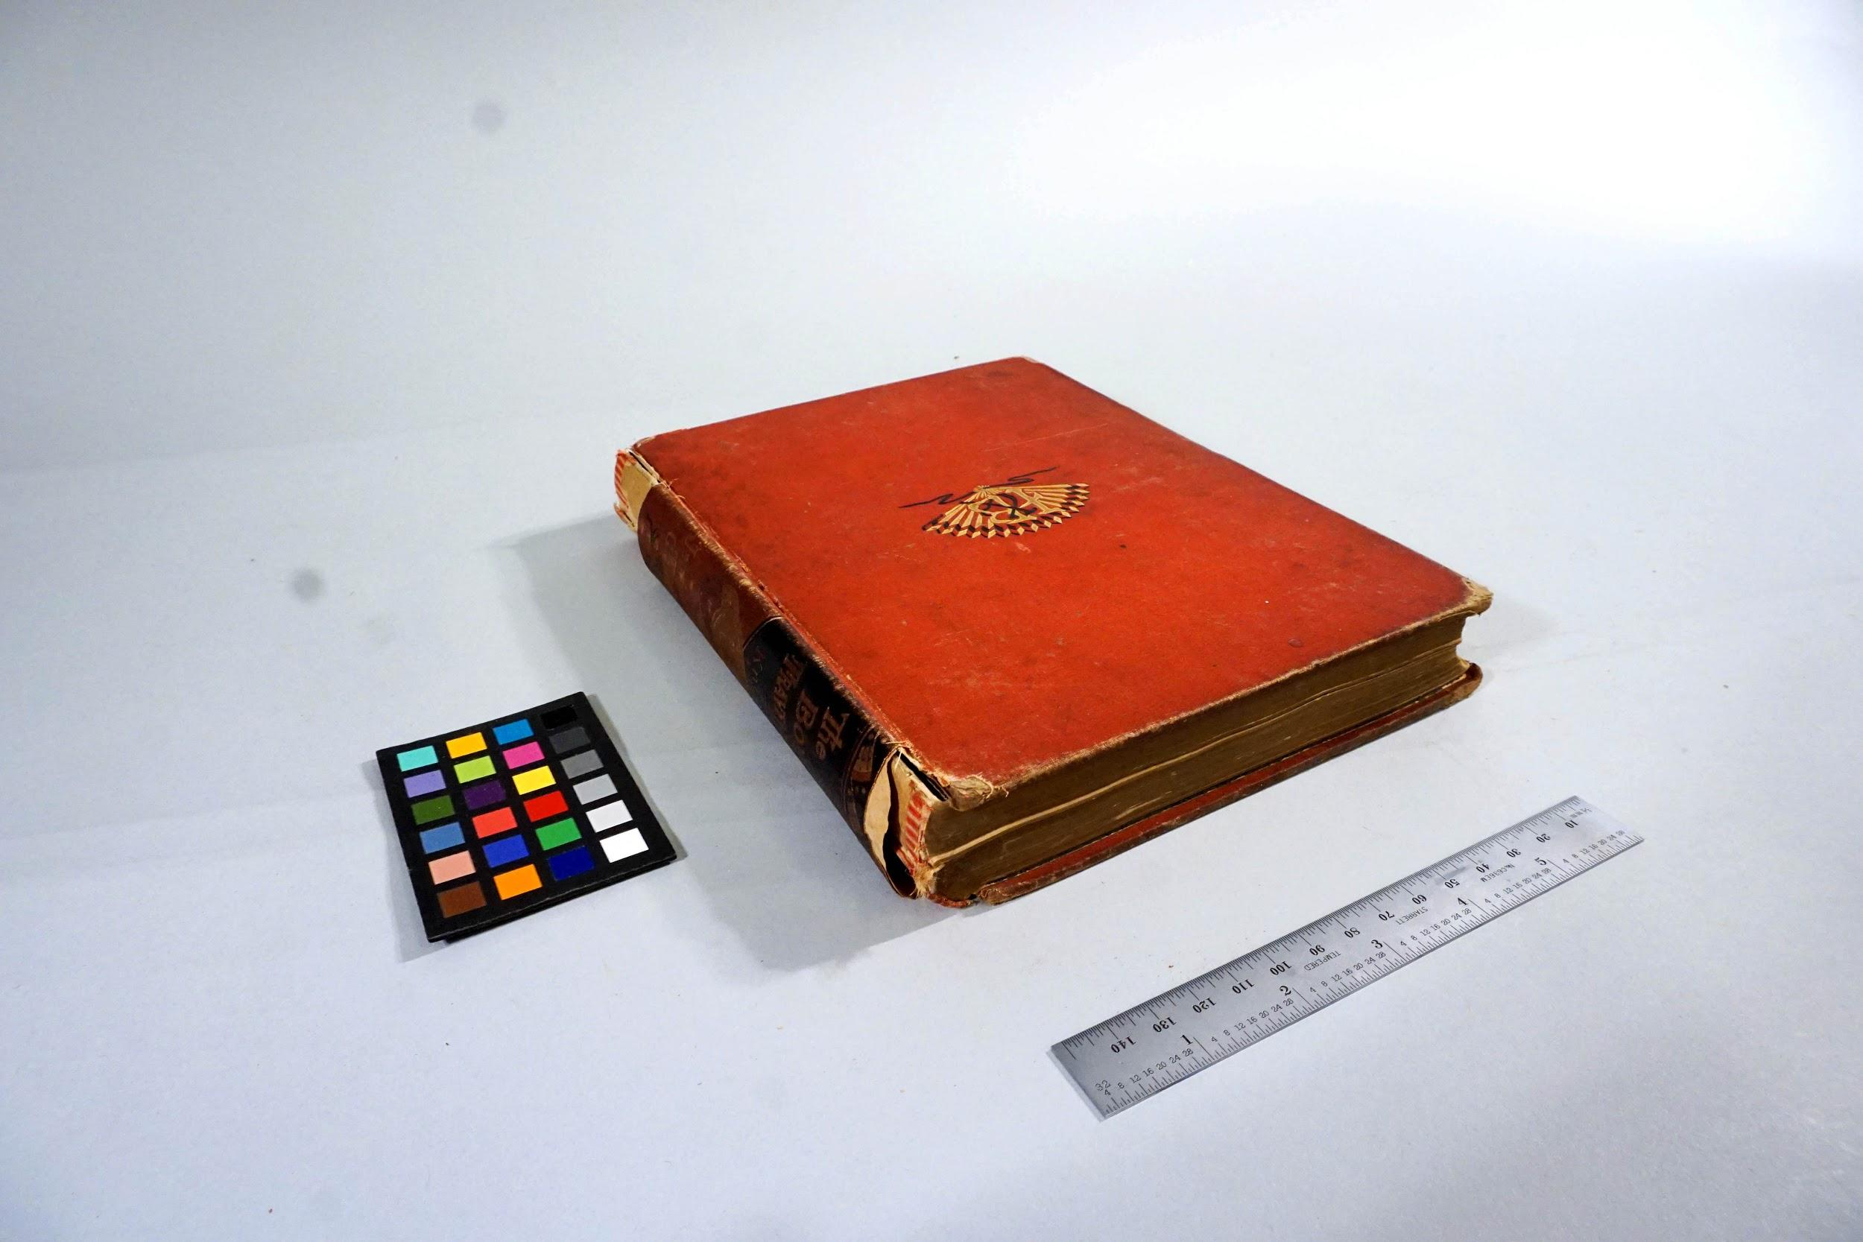

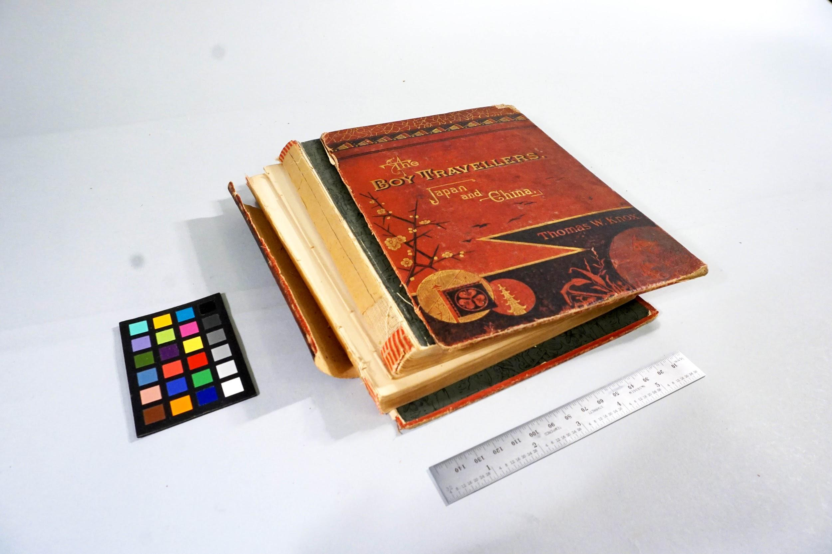

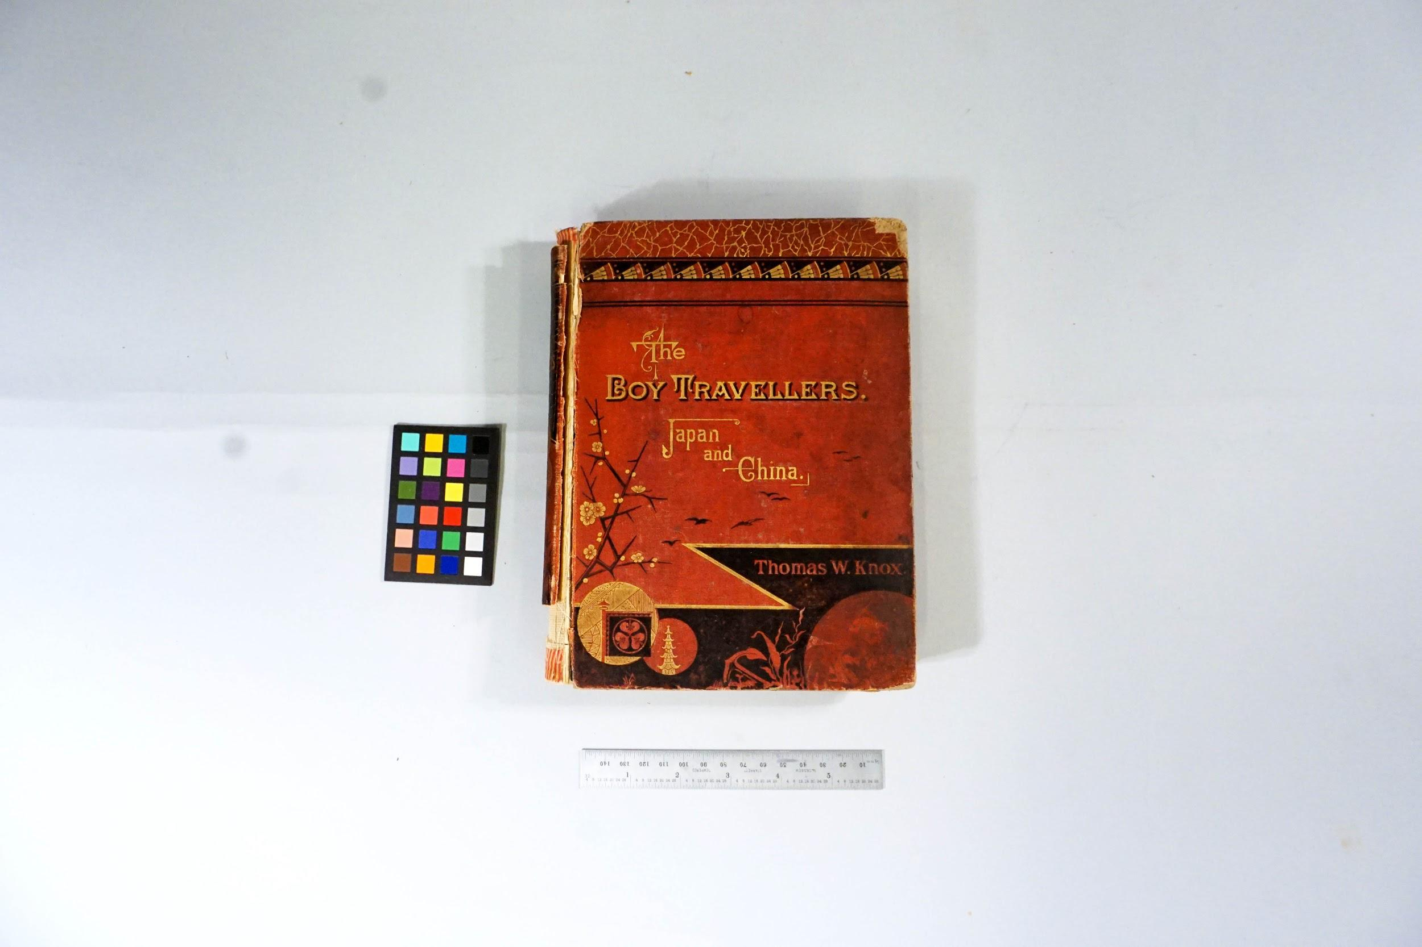

During:

**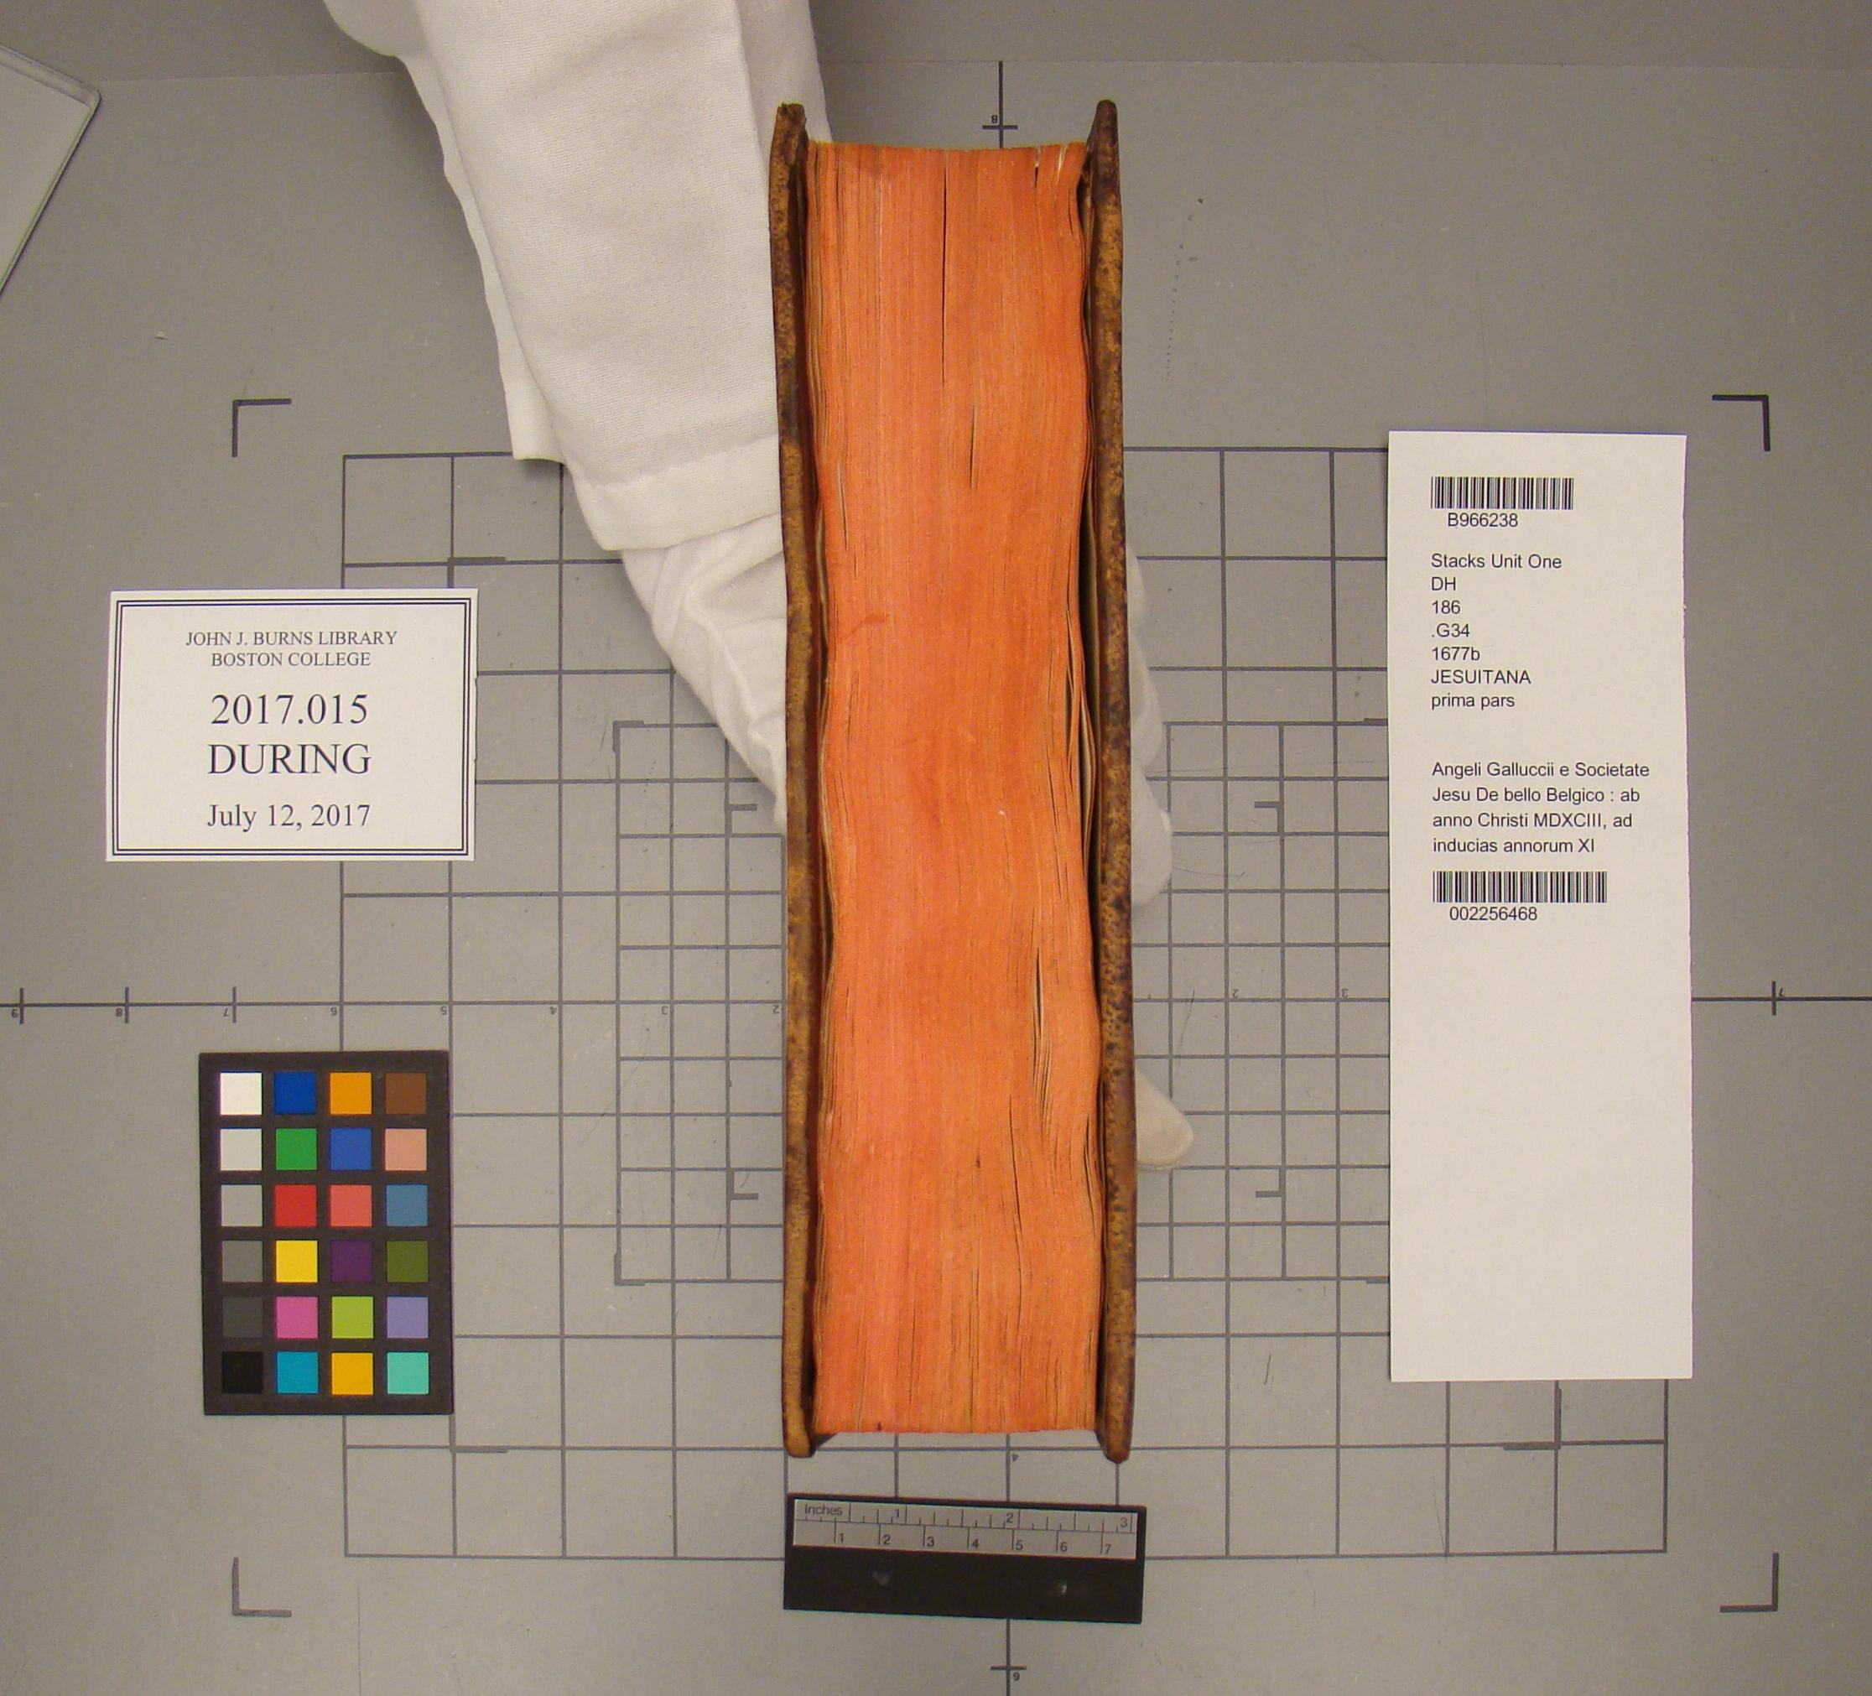  
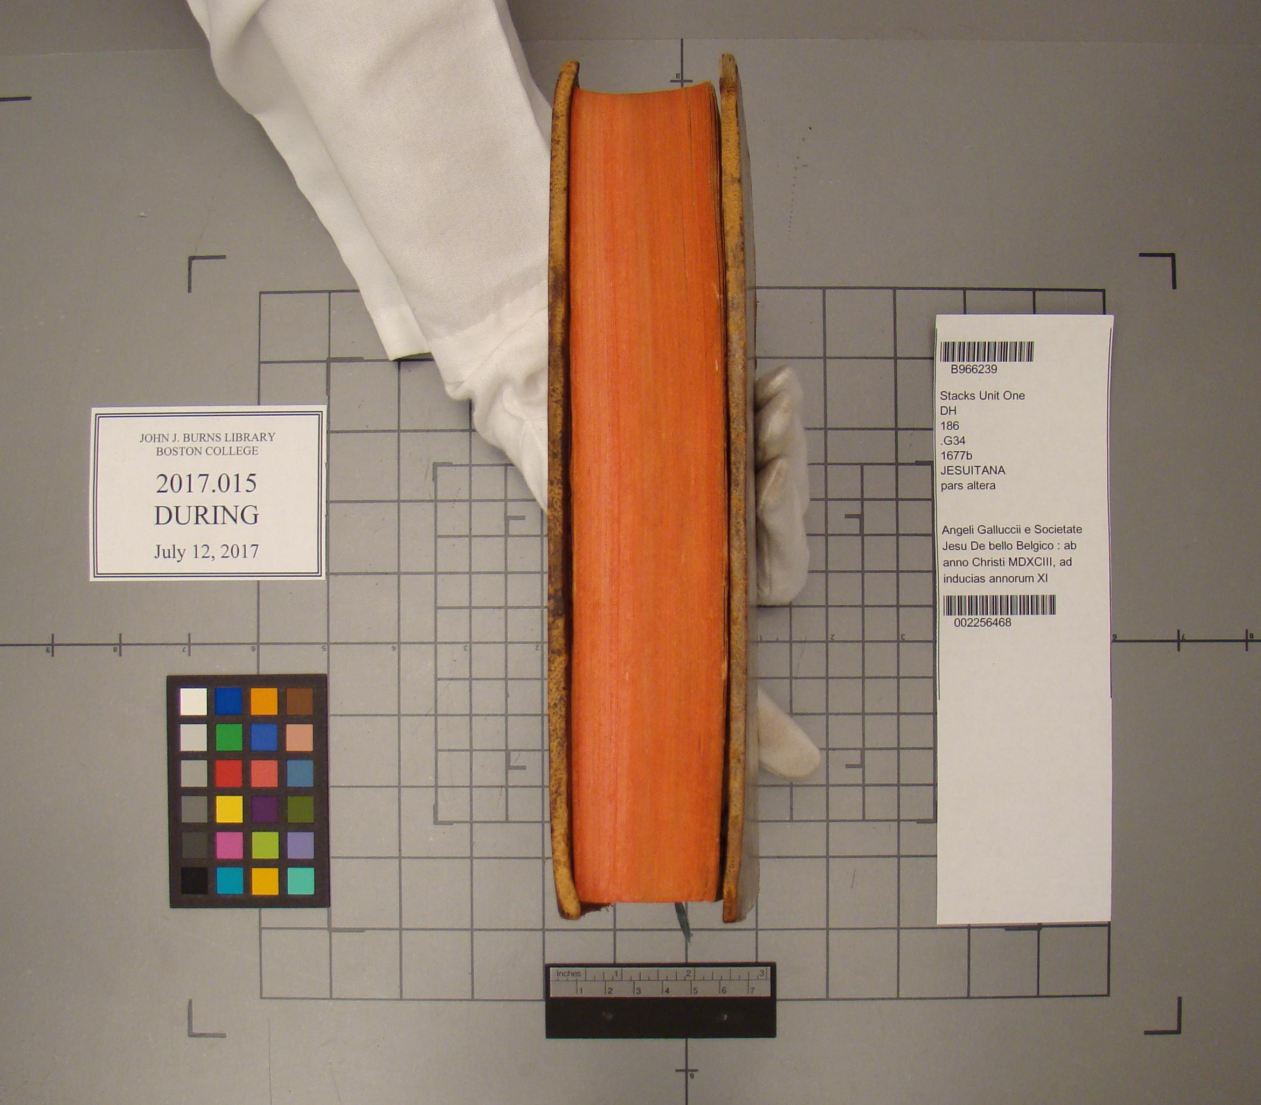**

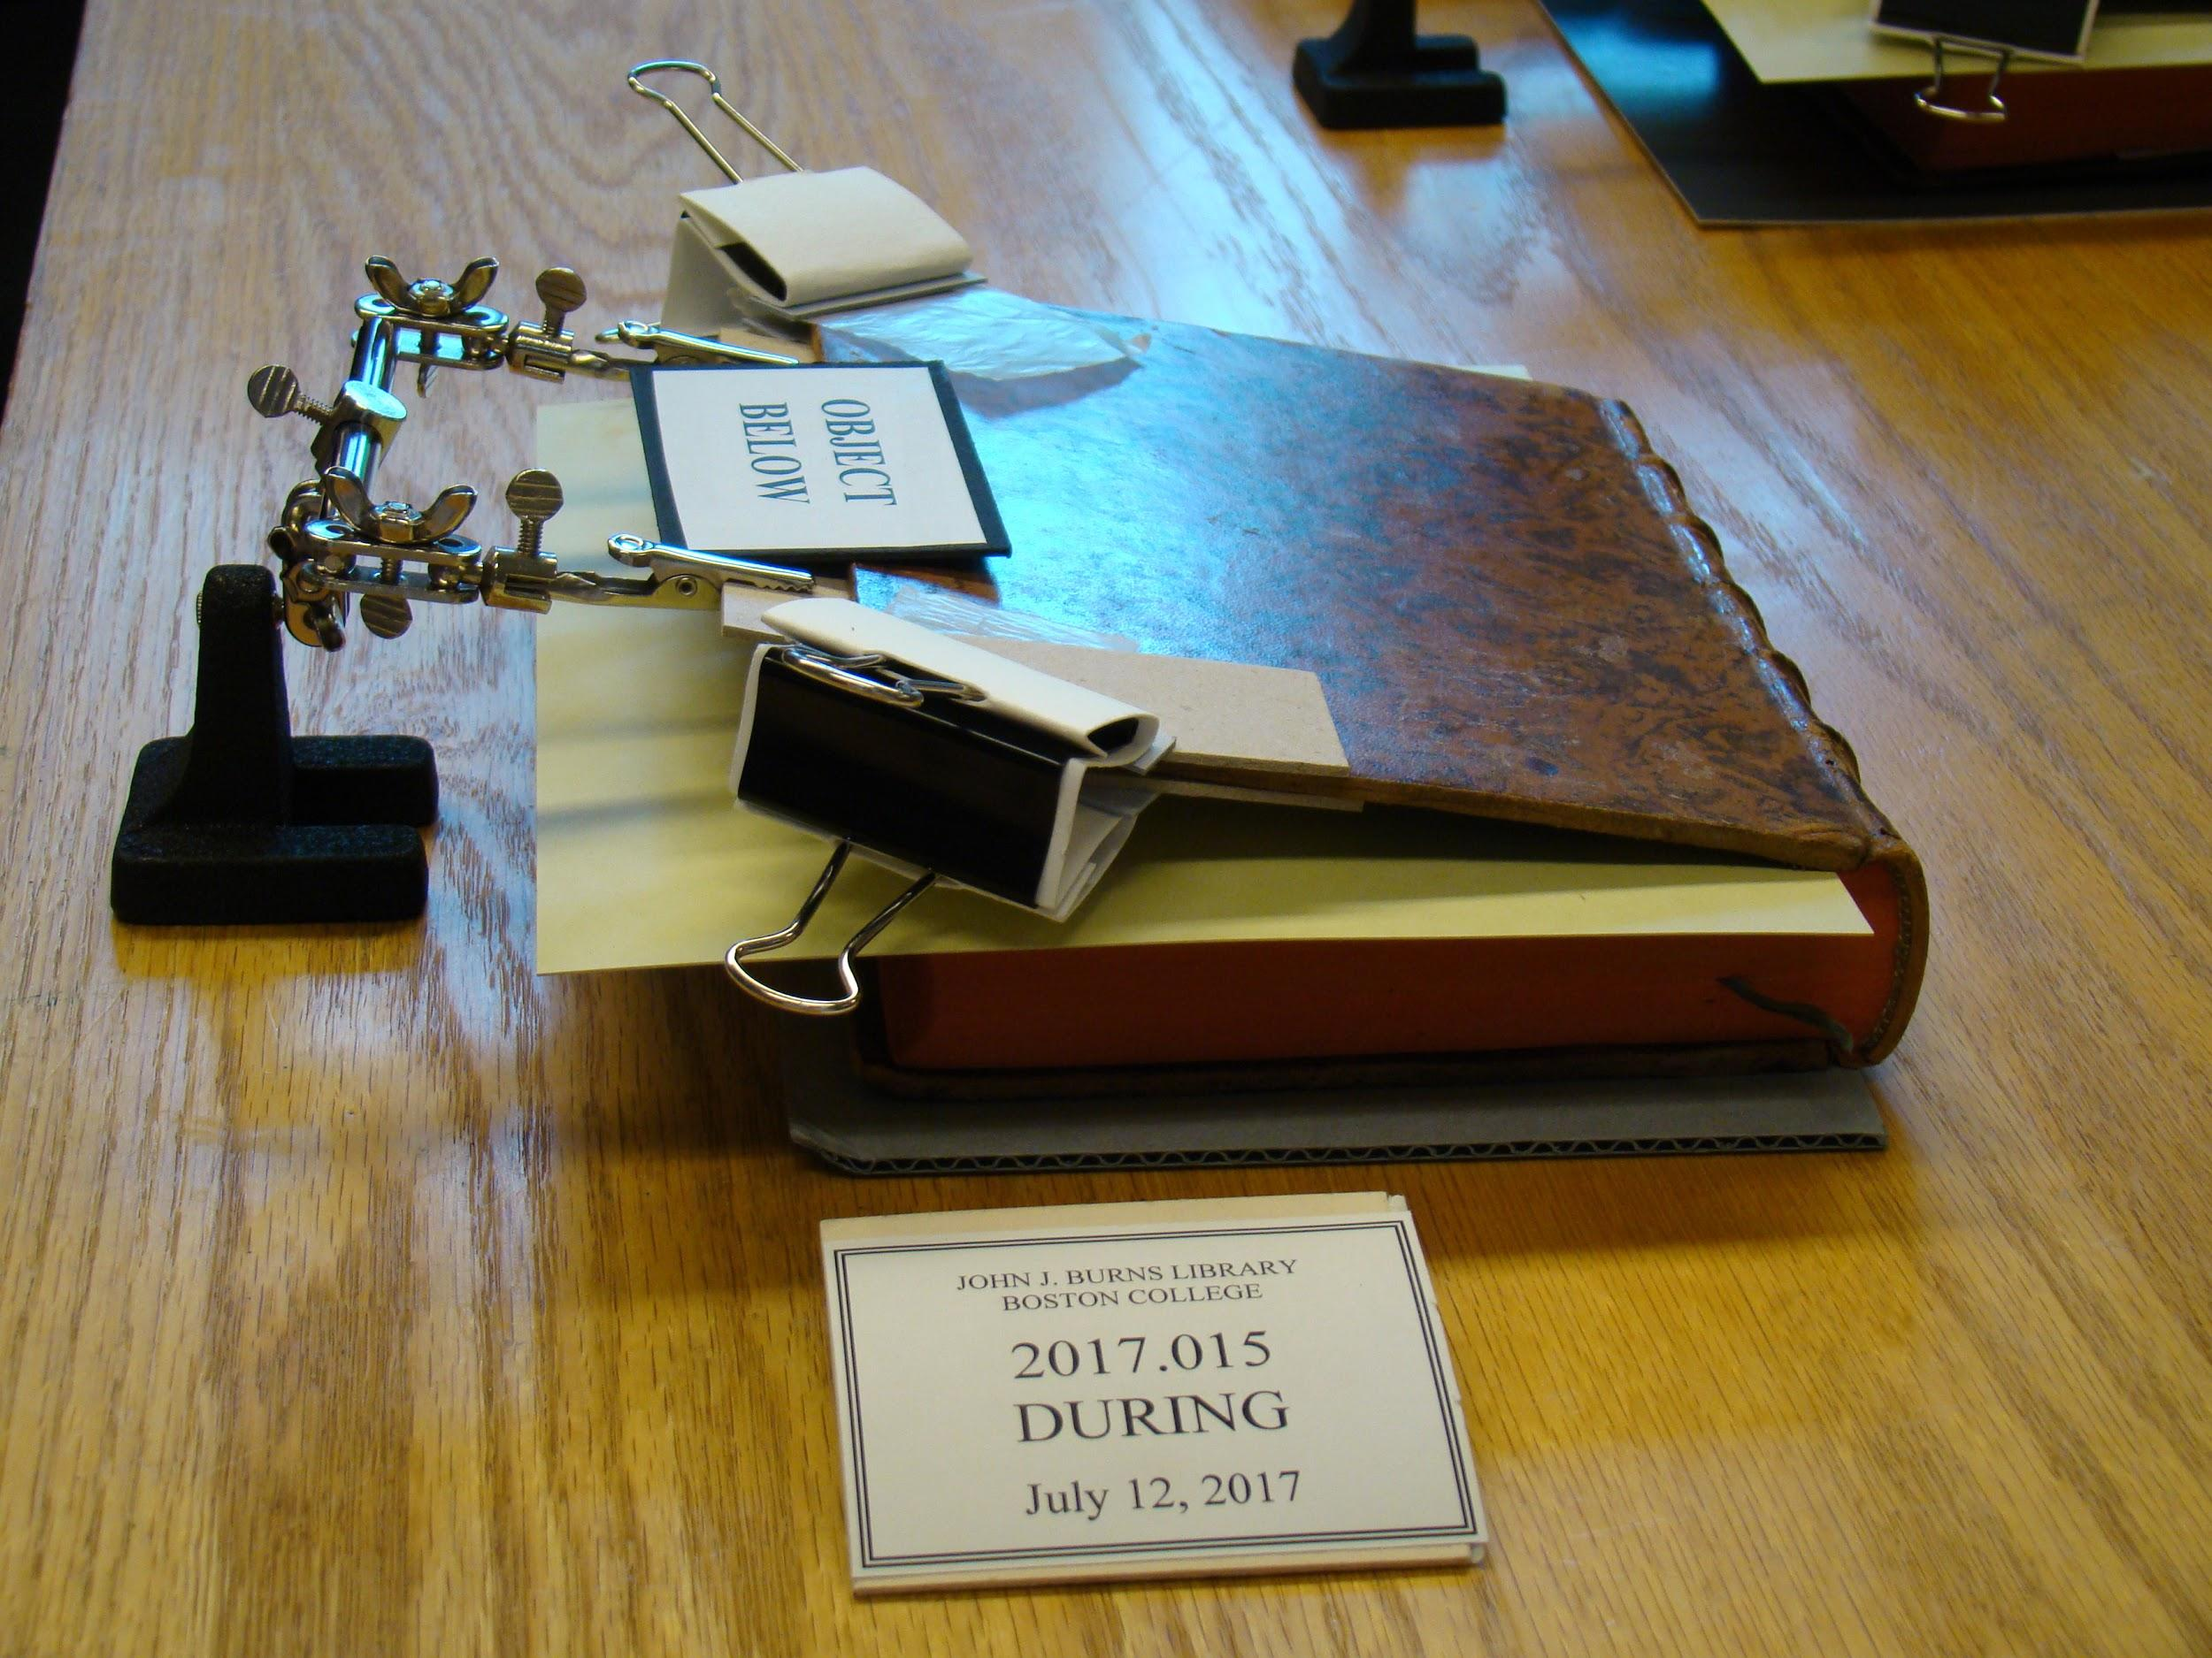

After:

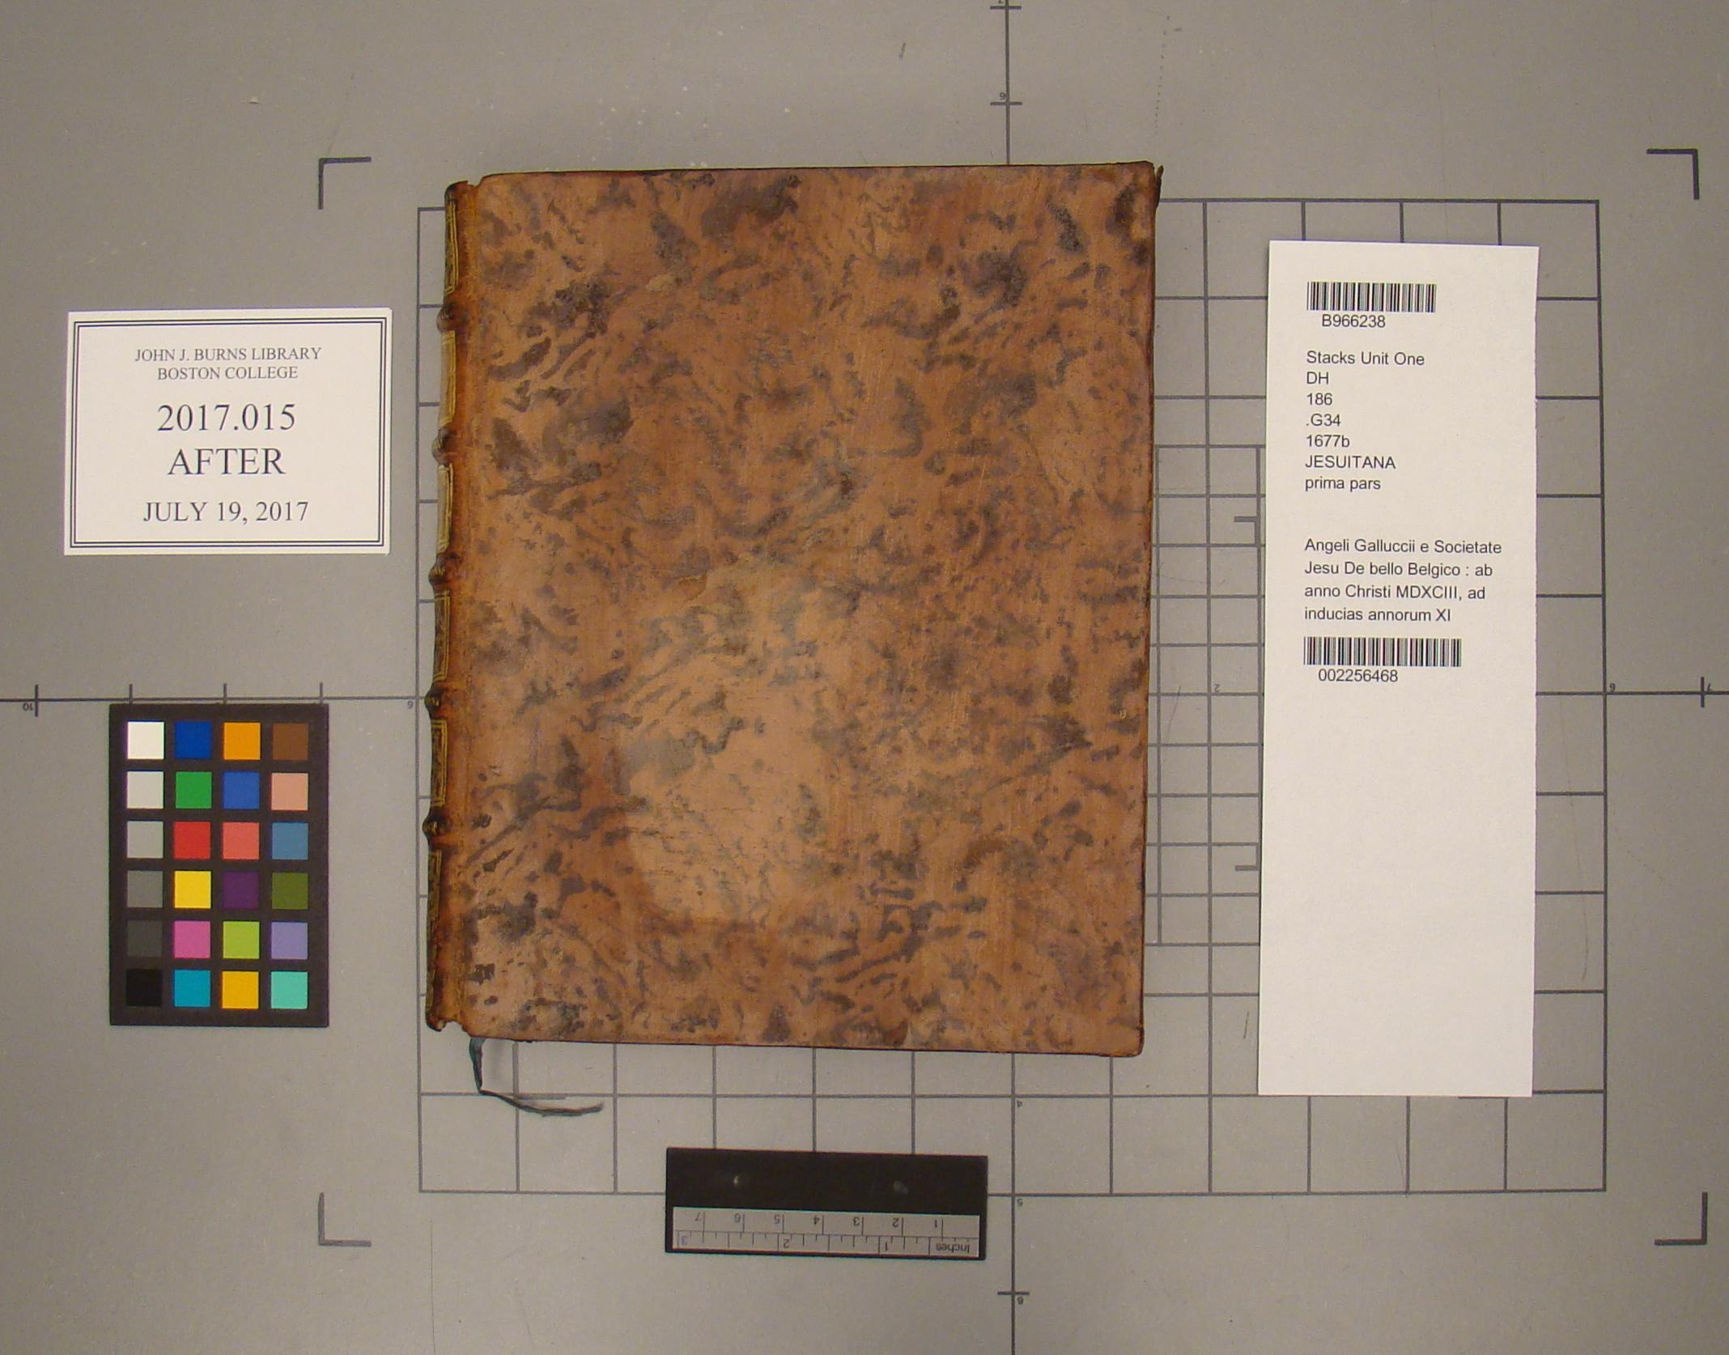

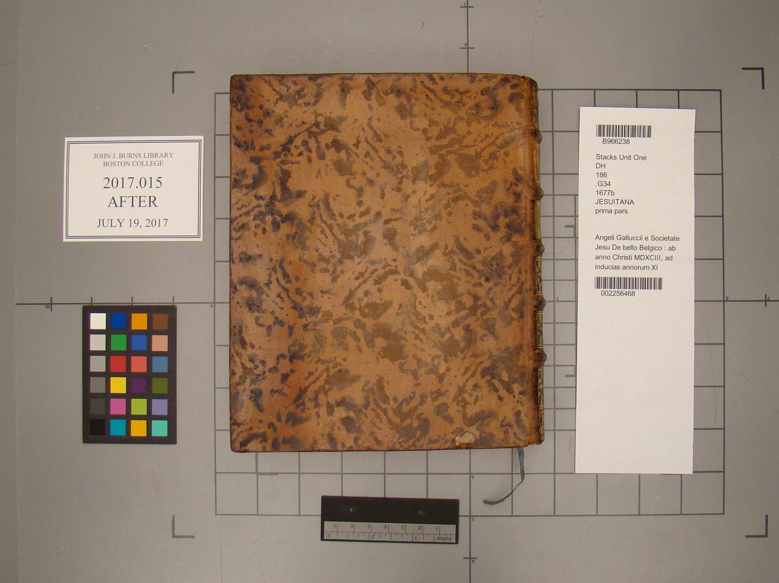

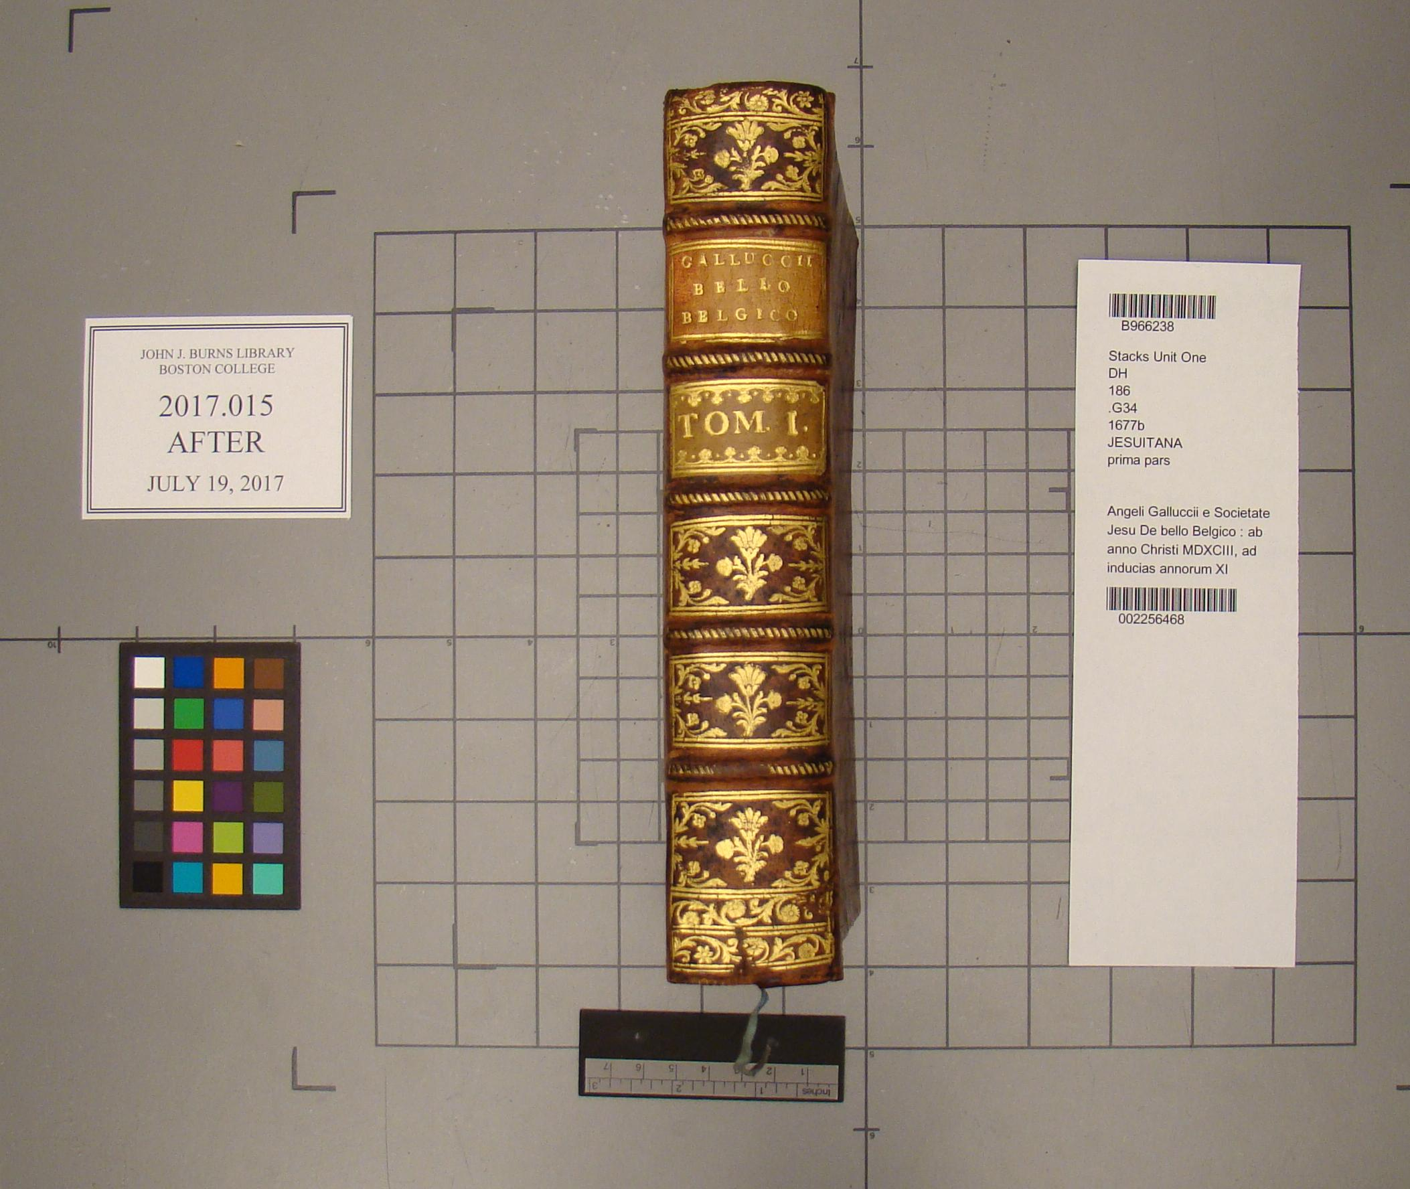

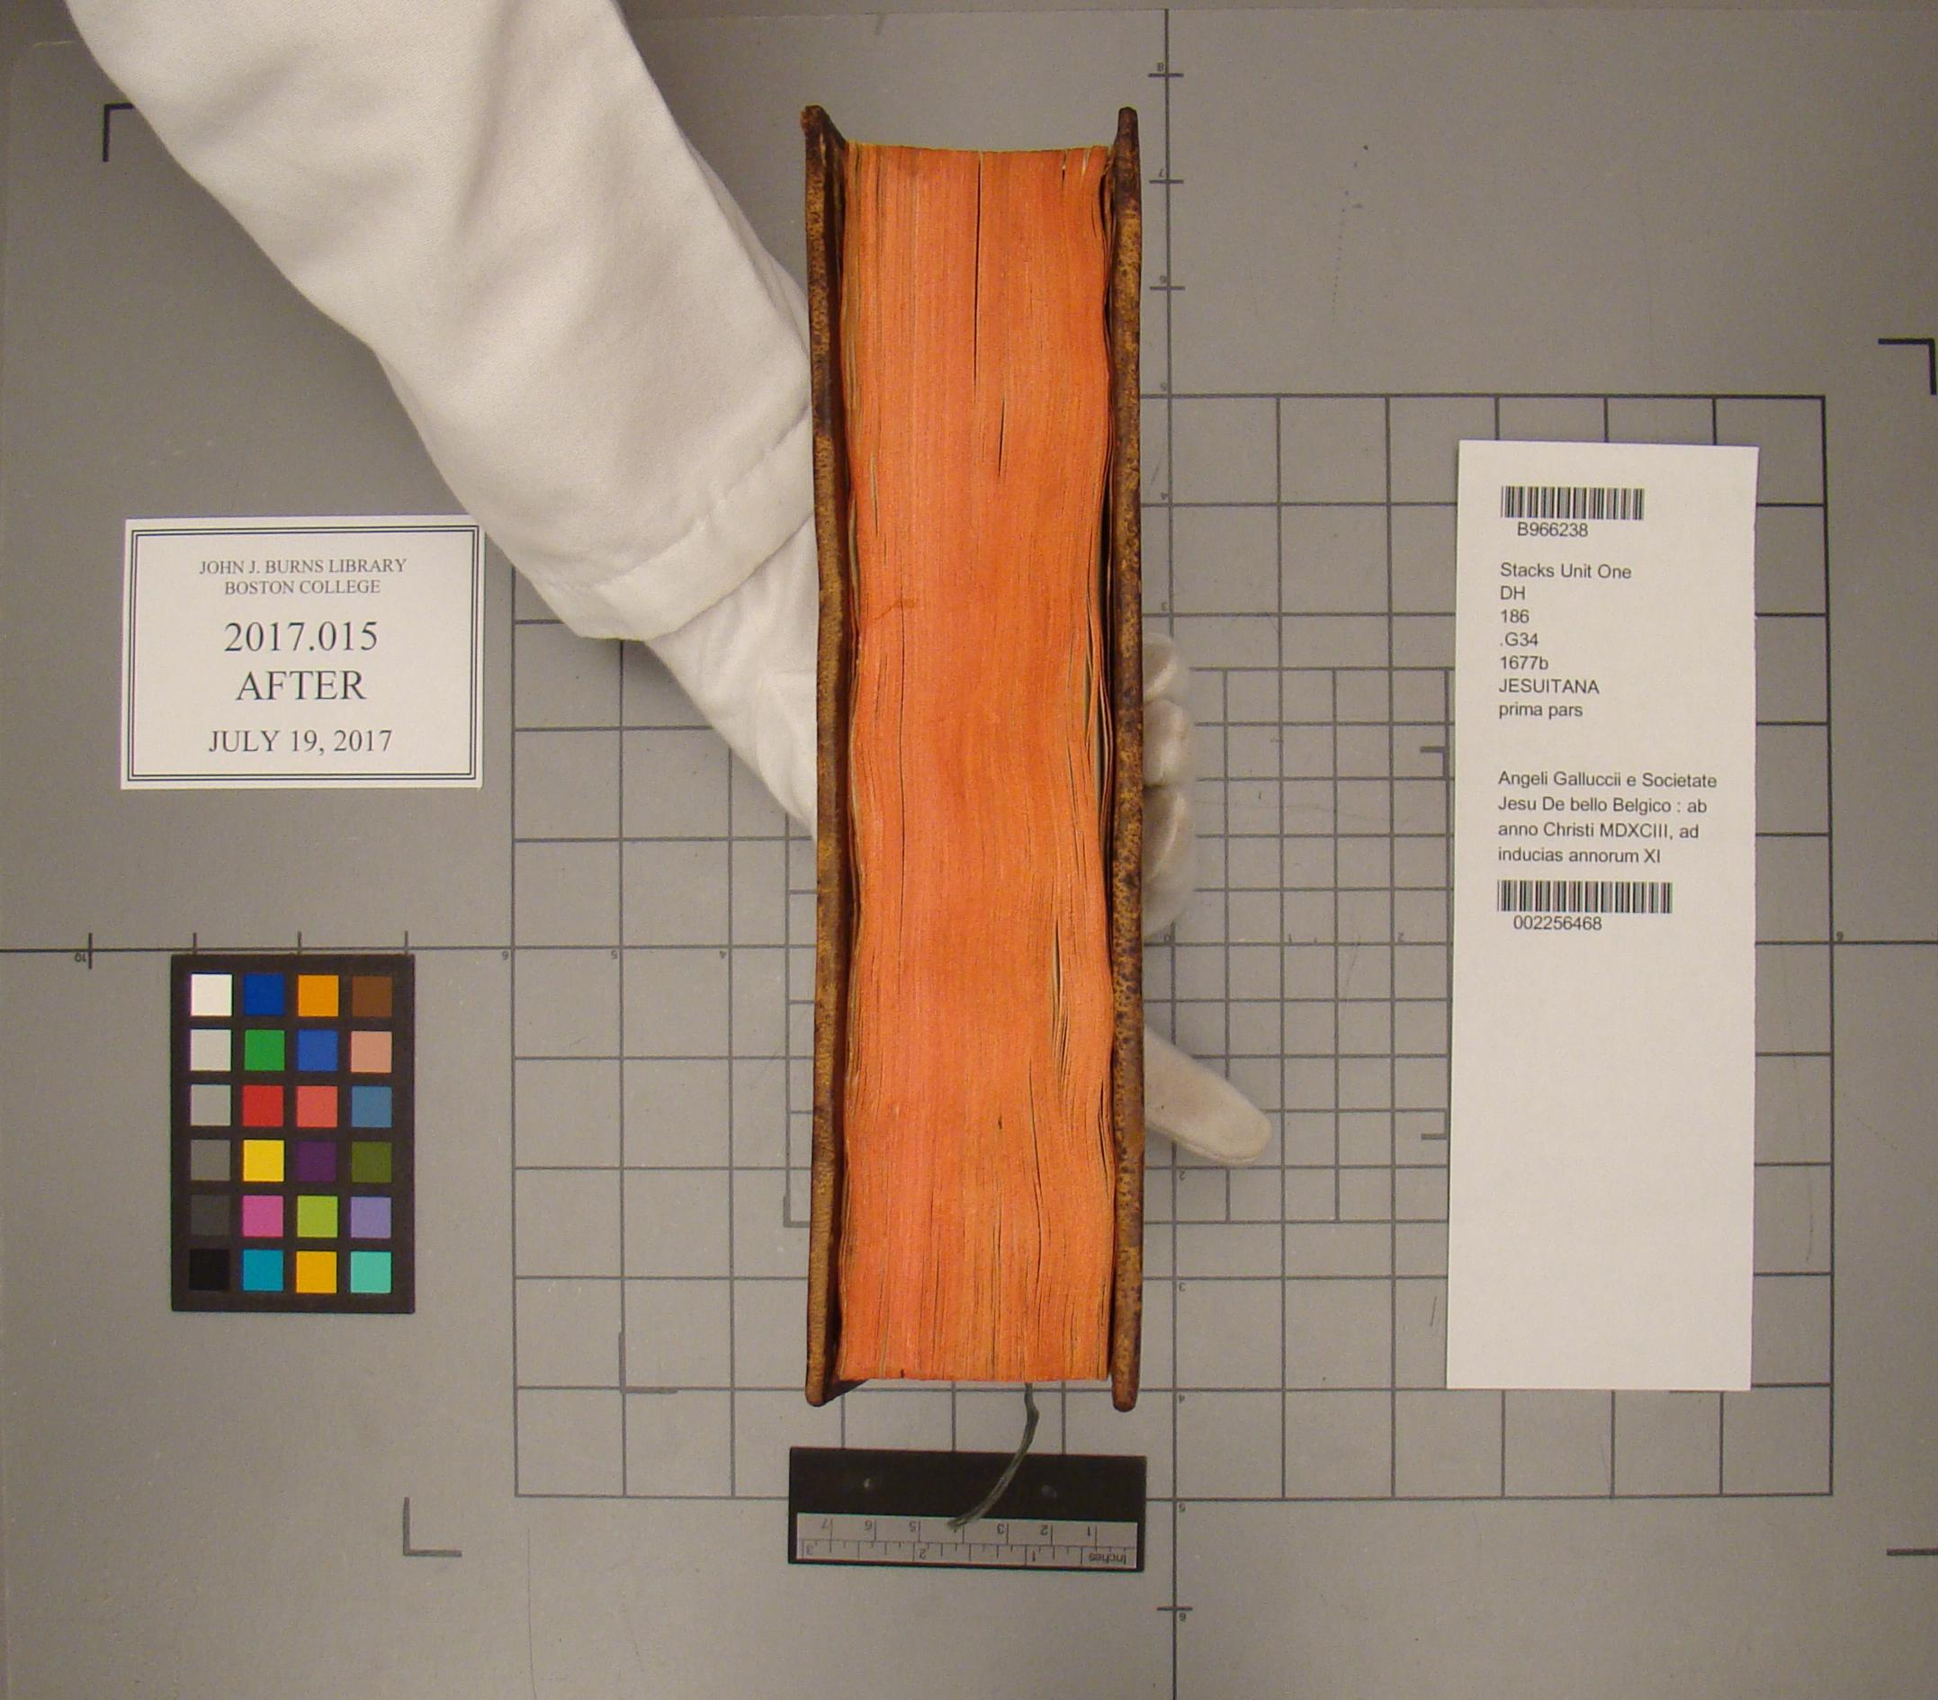

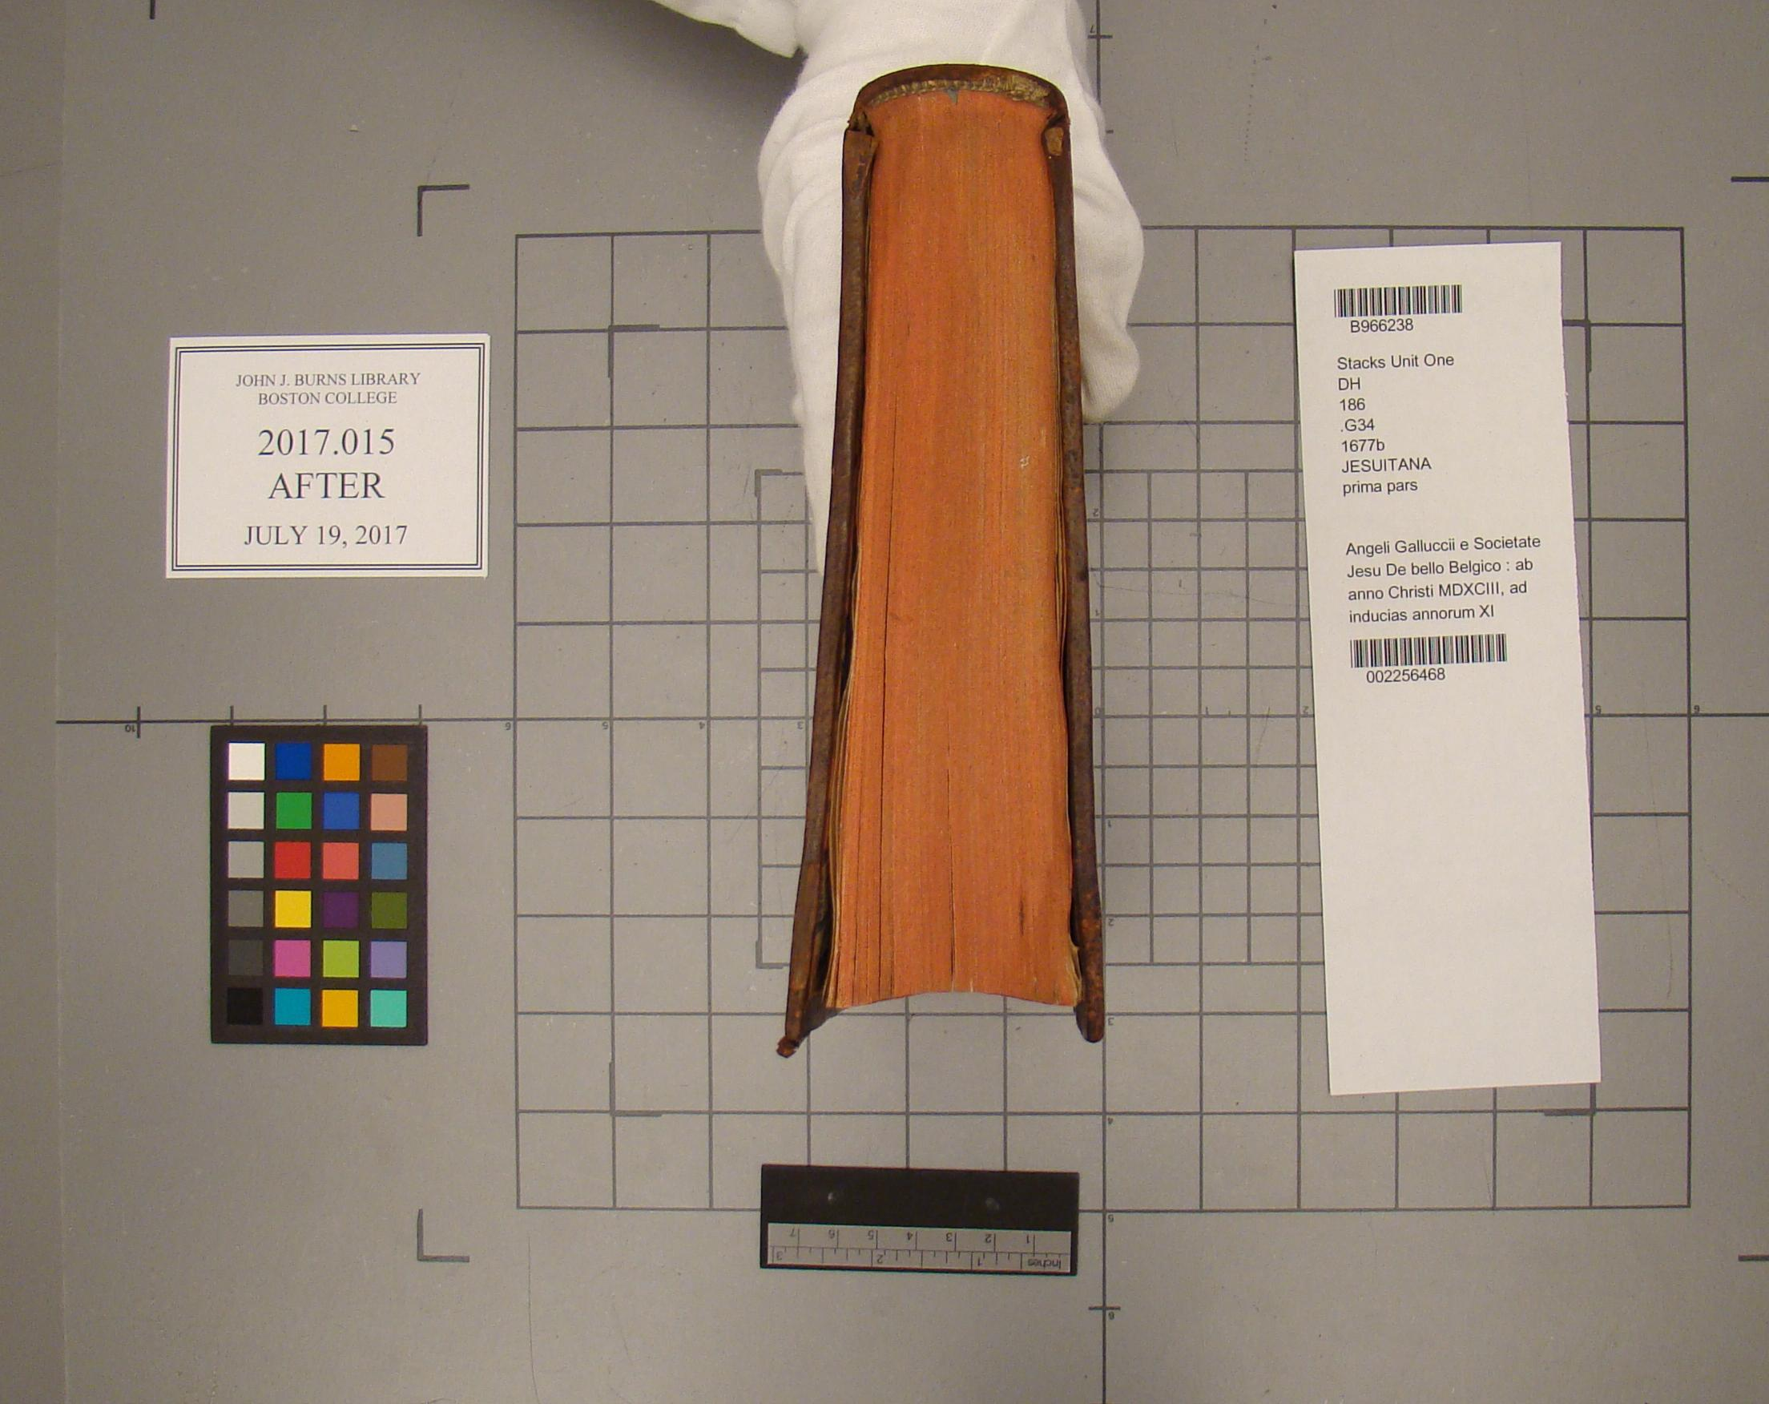

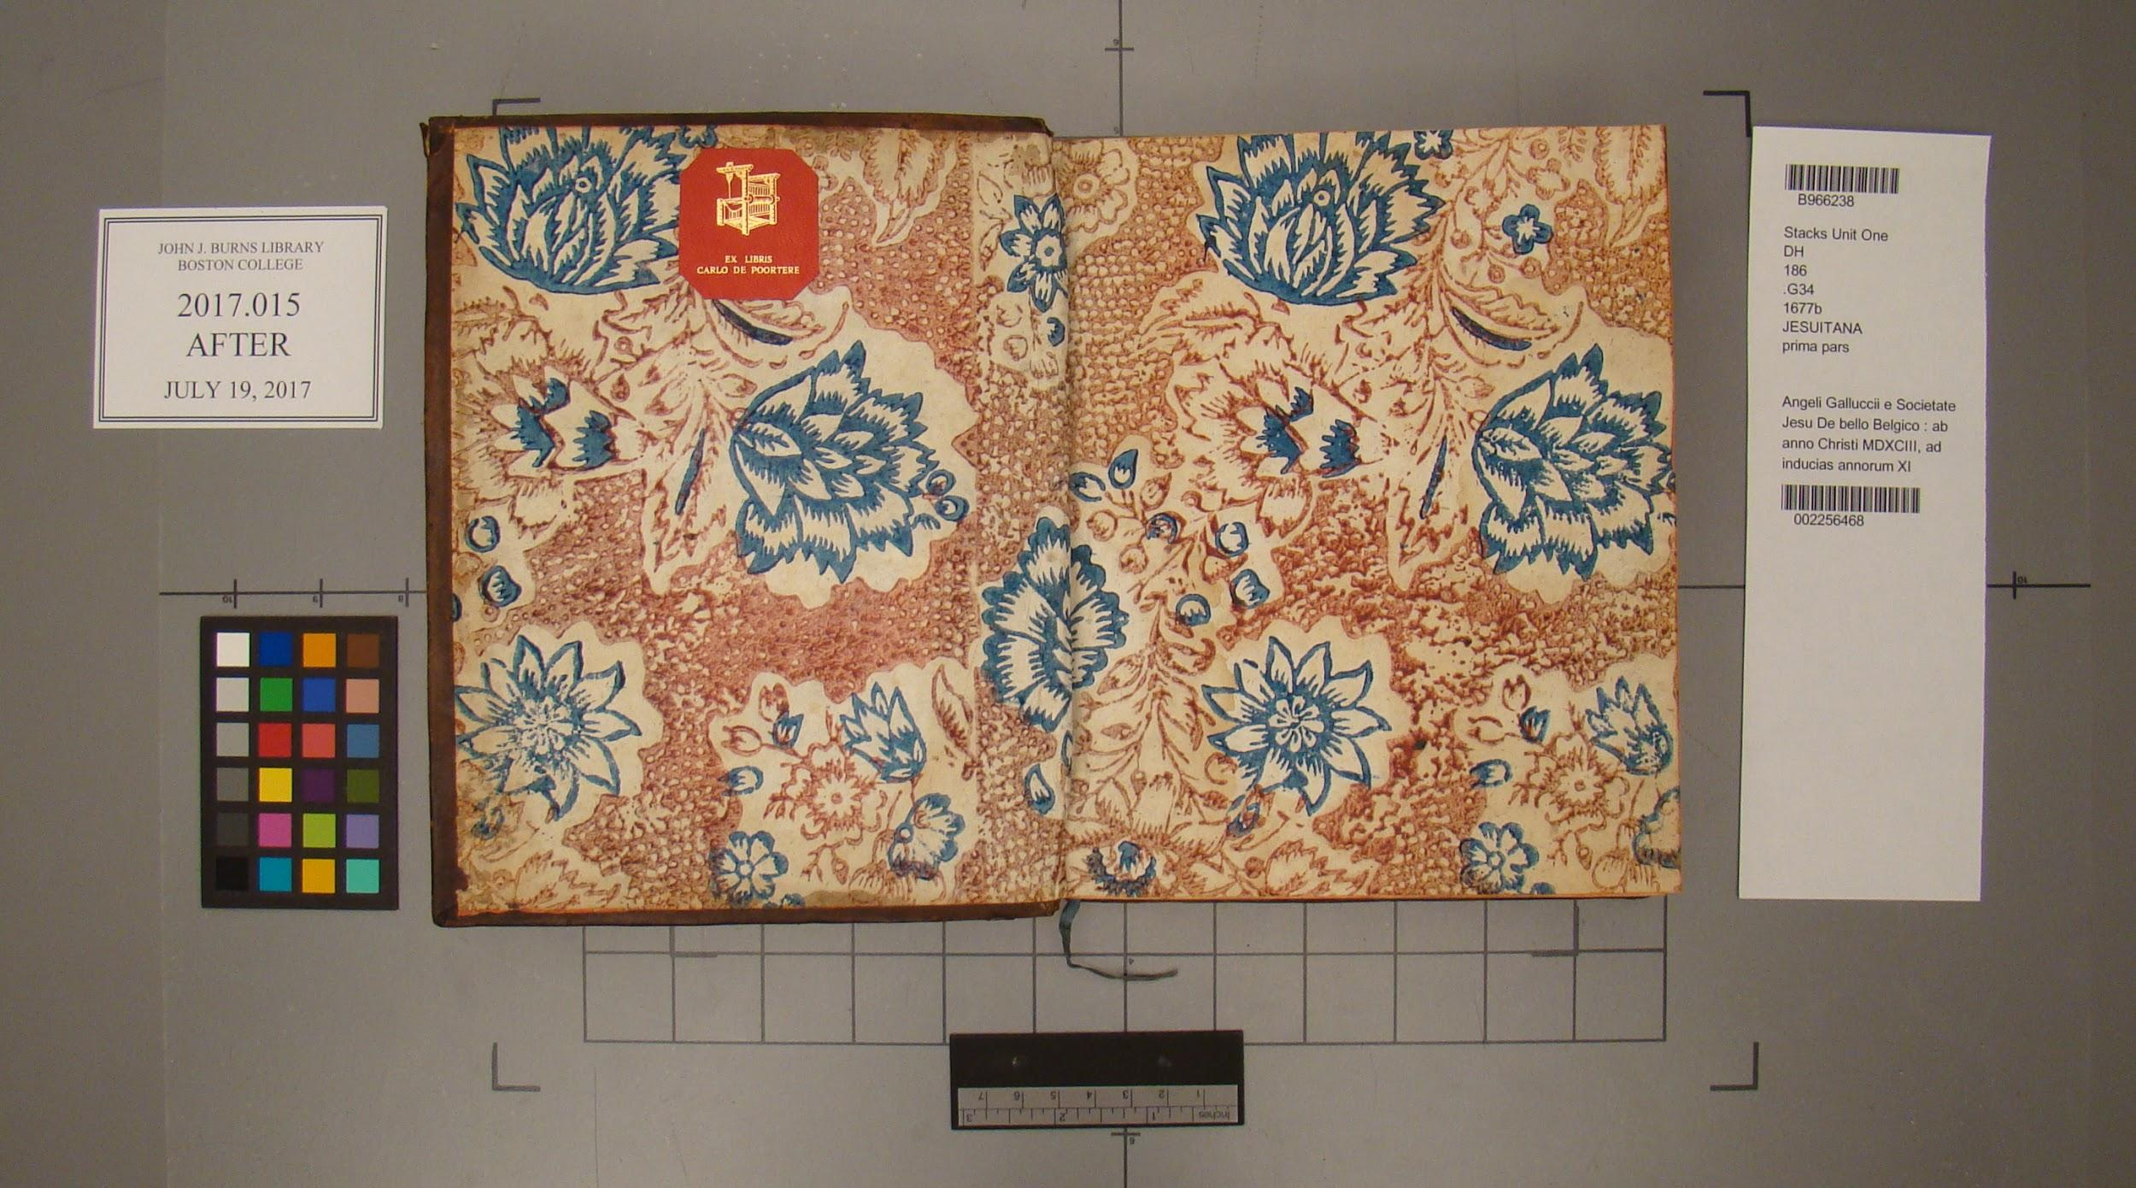

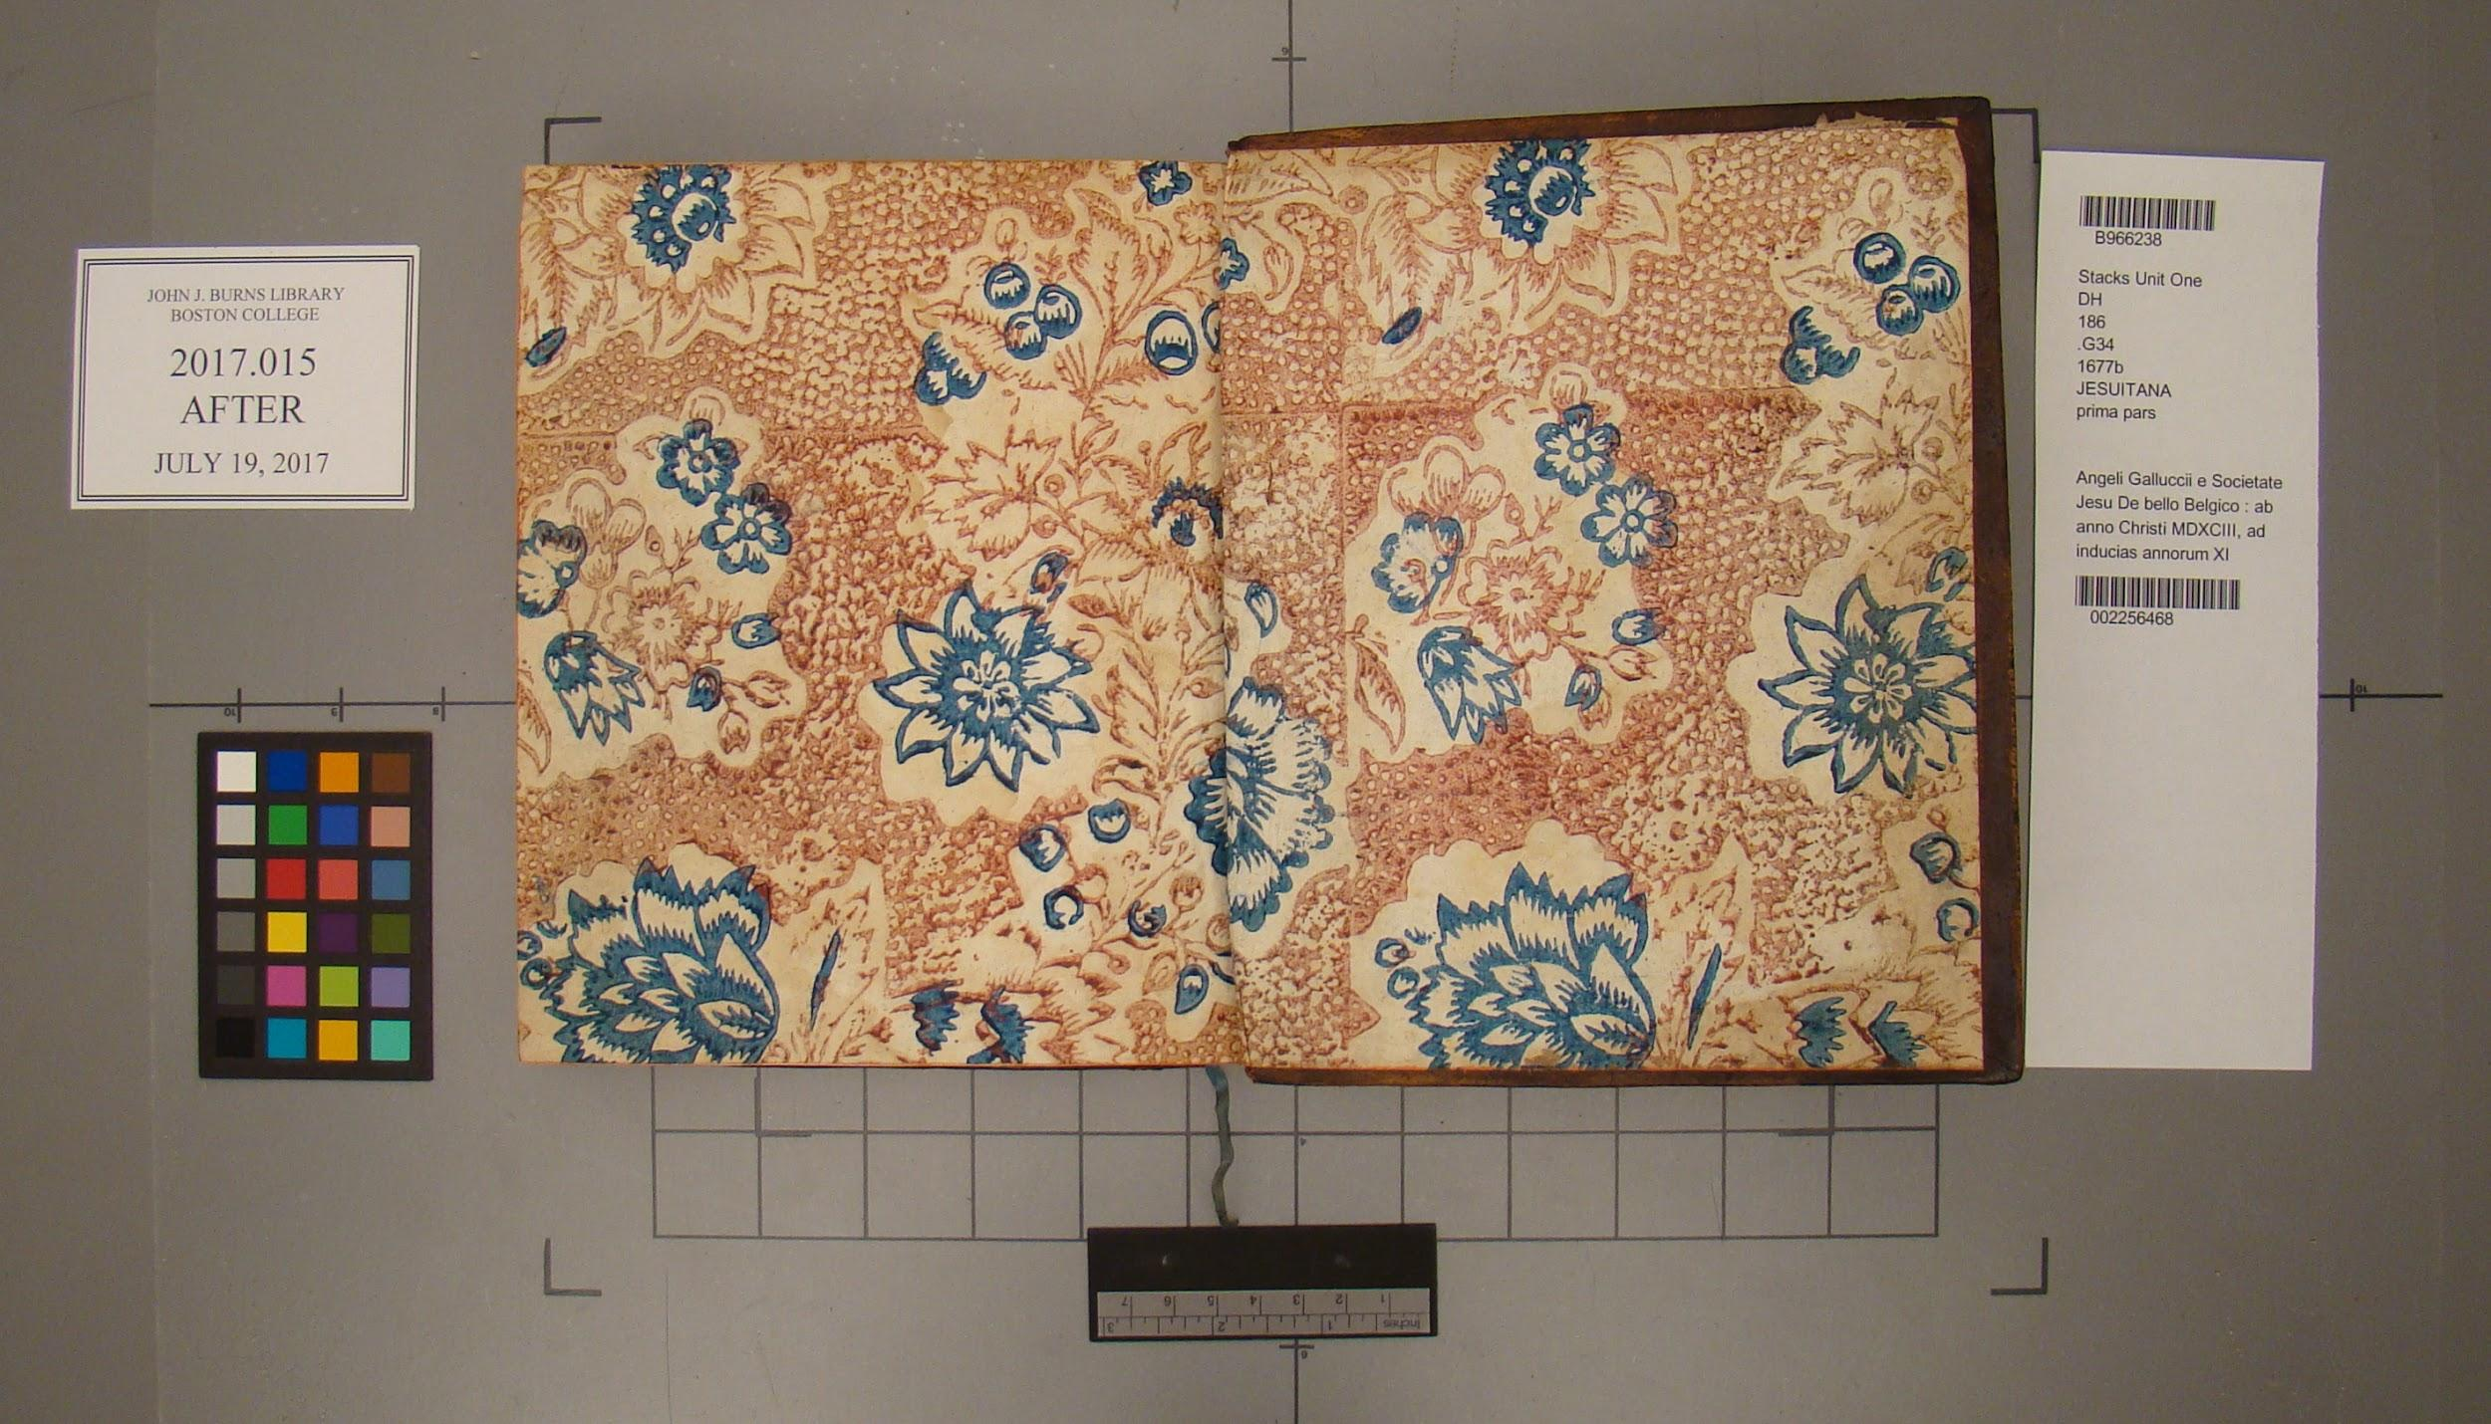

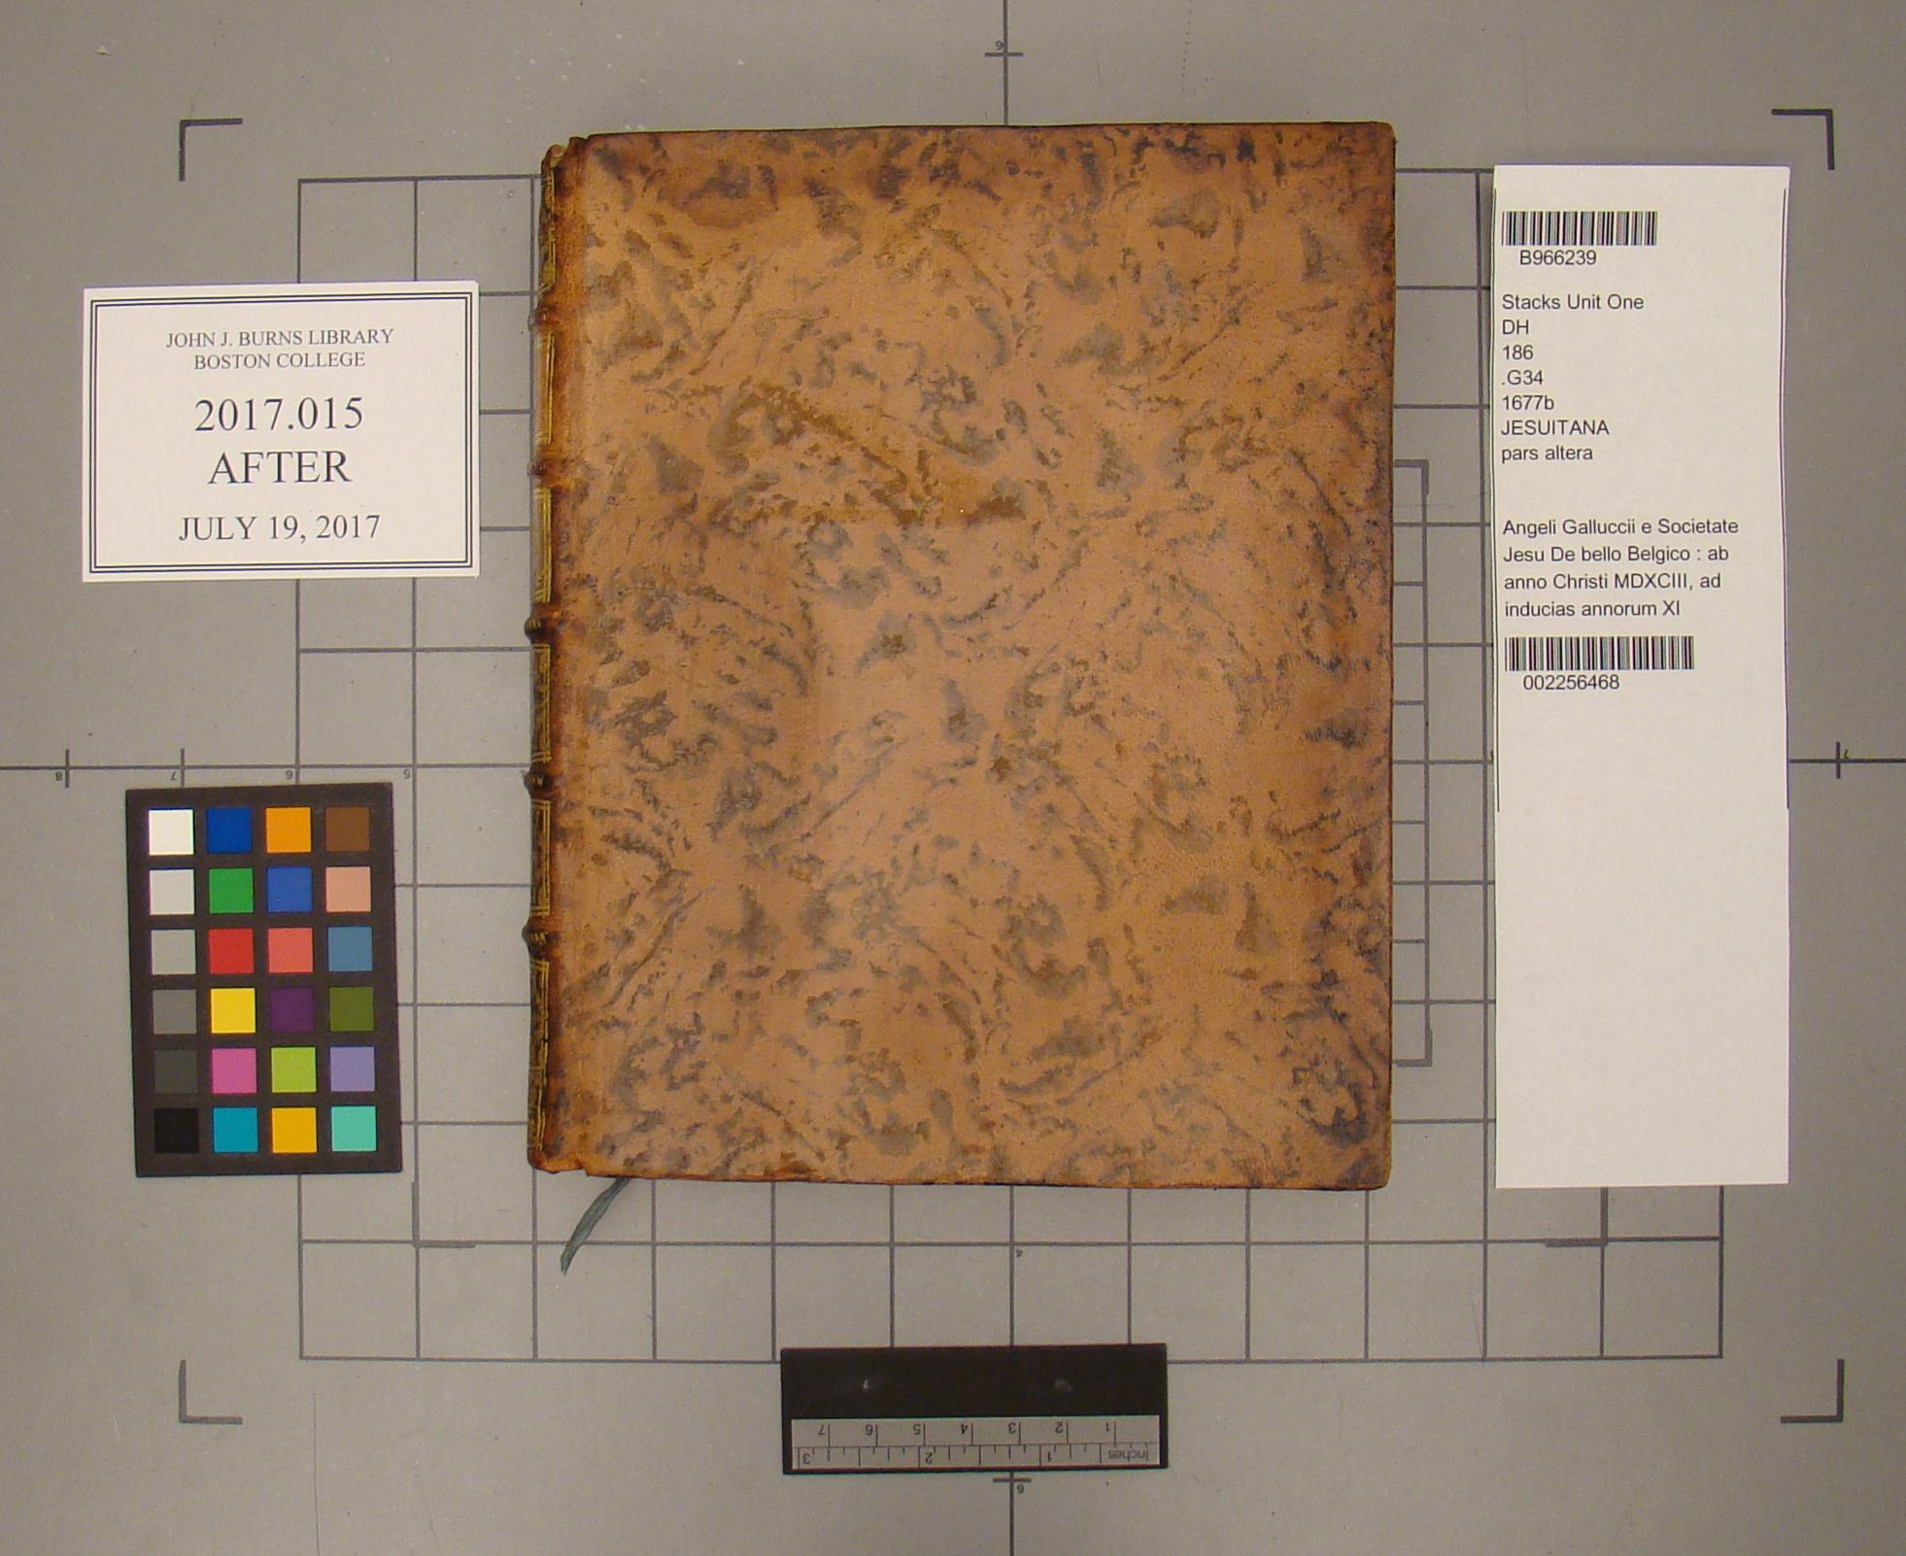

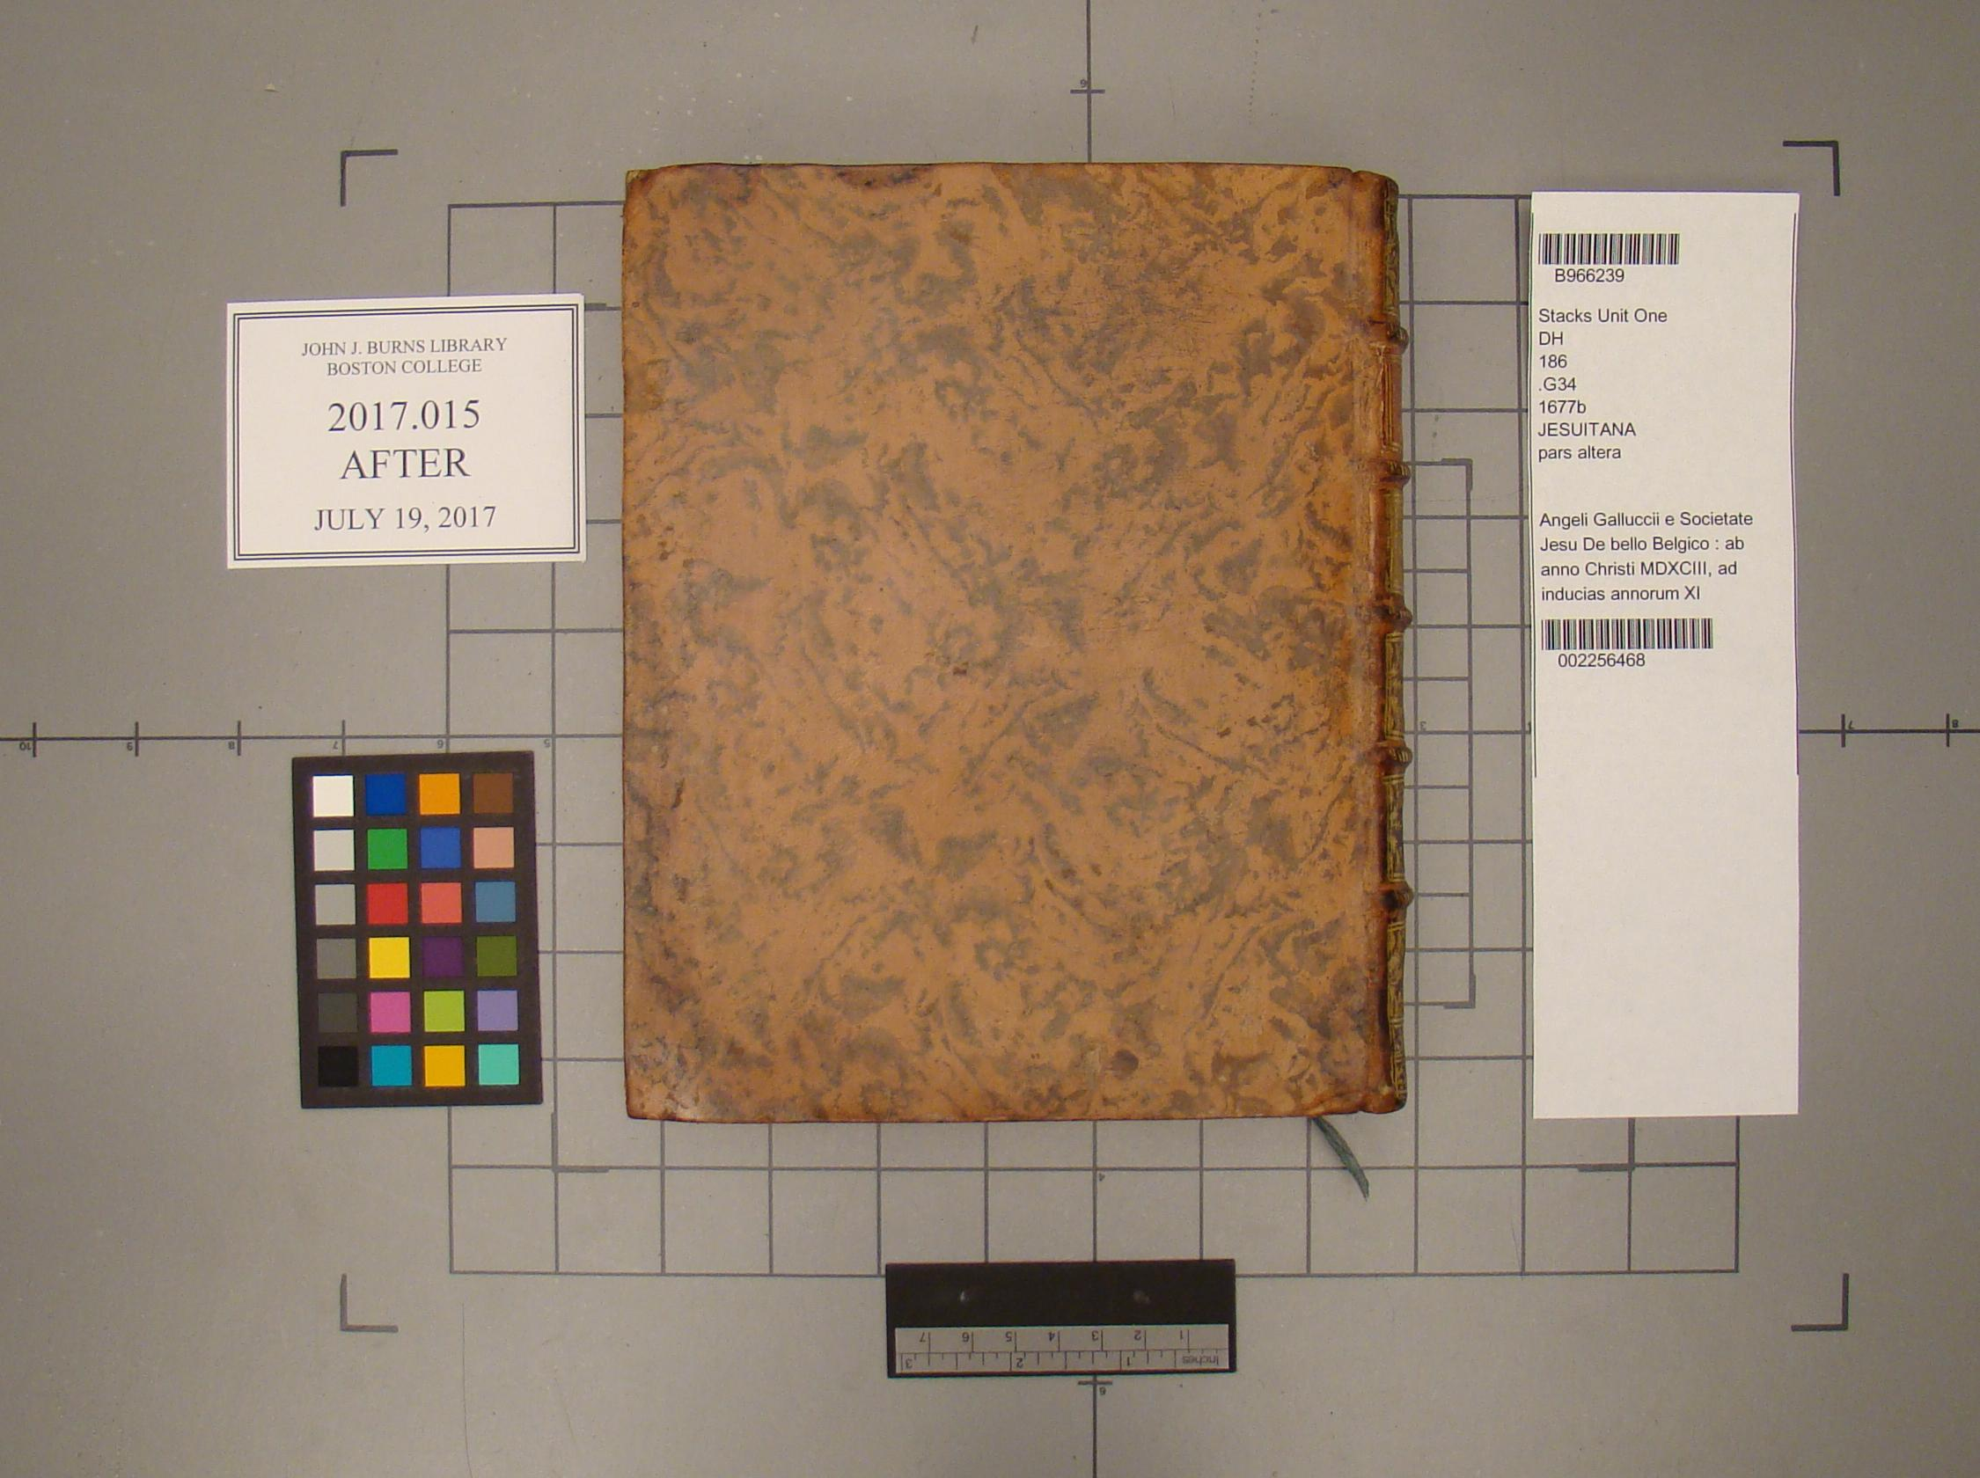

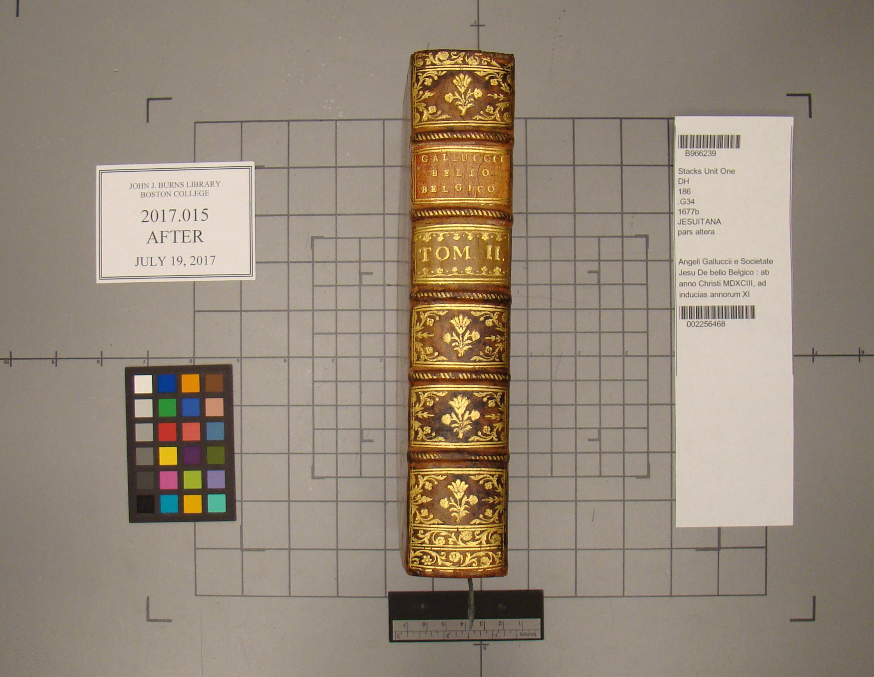

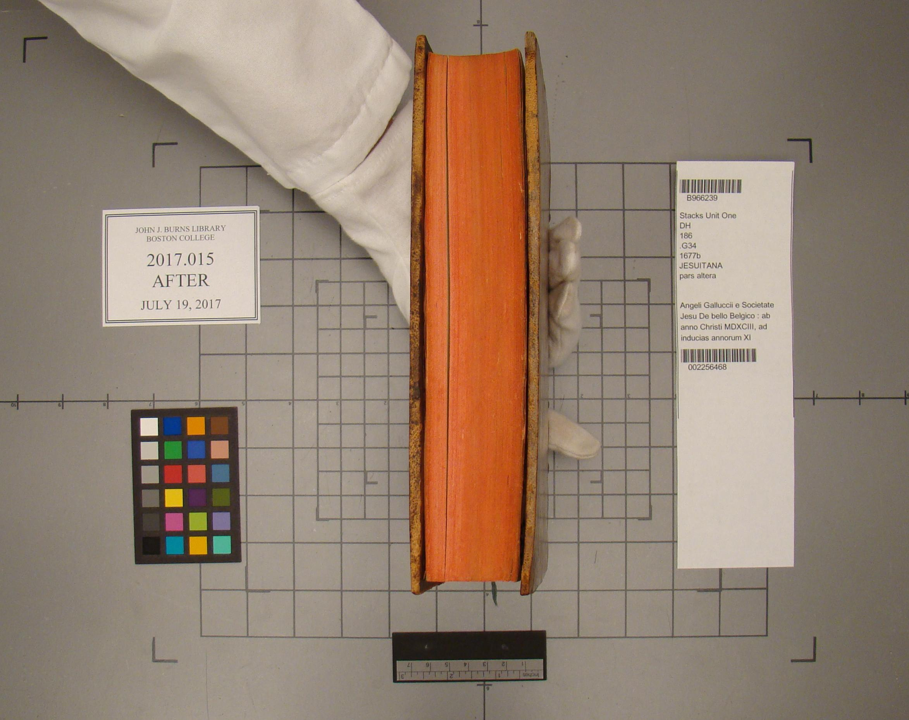

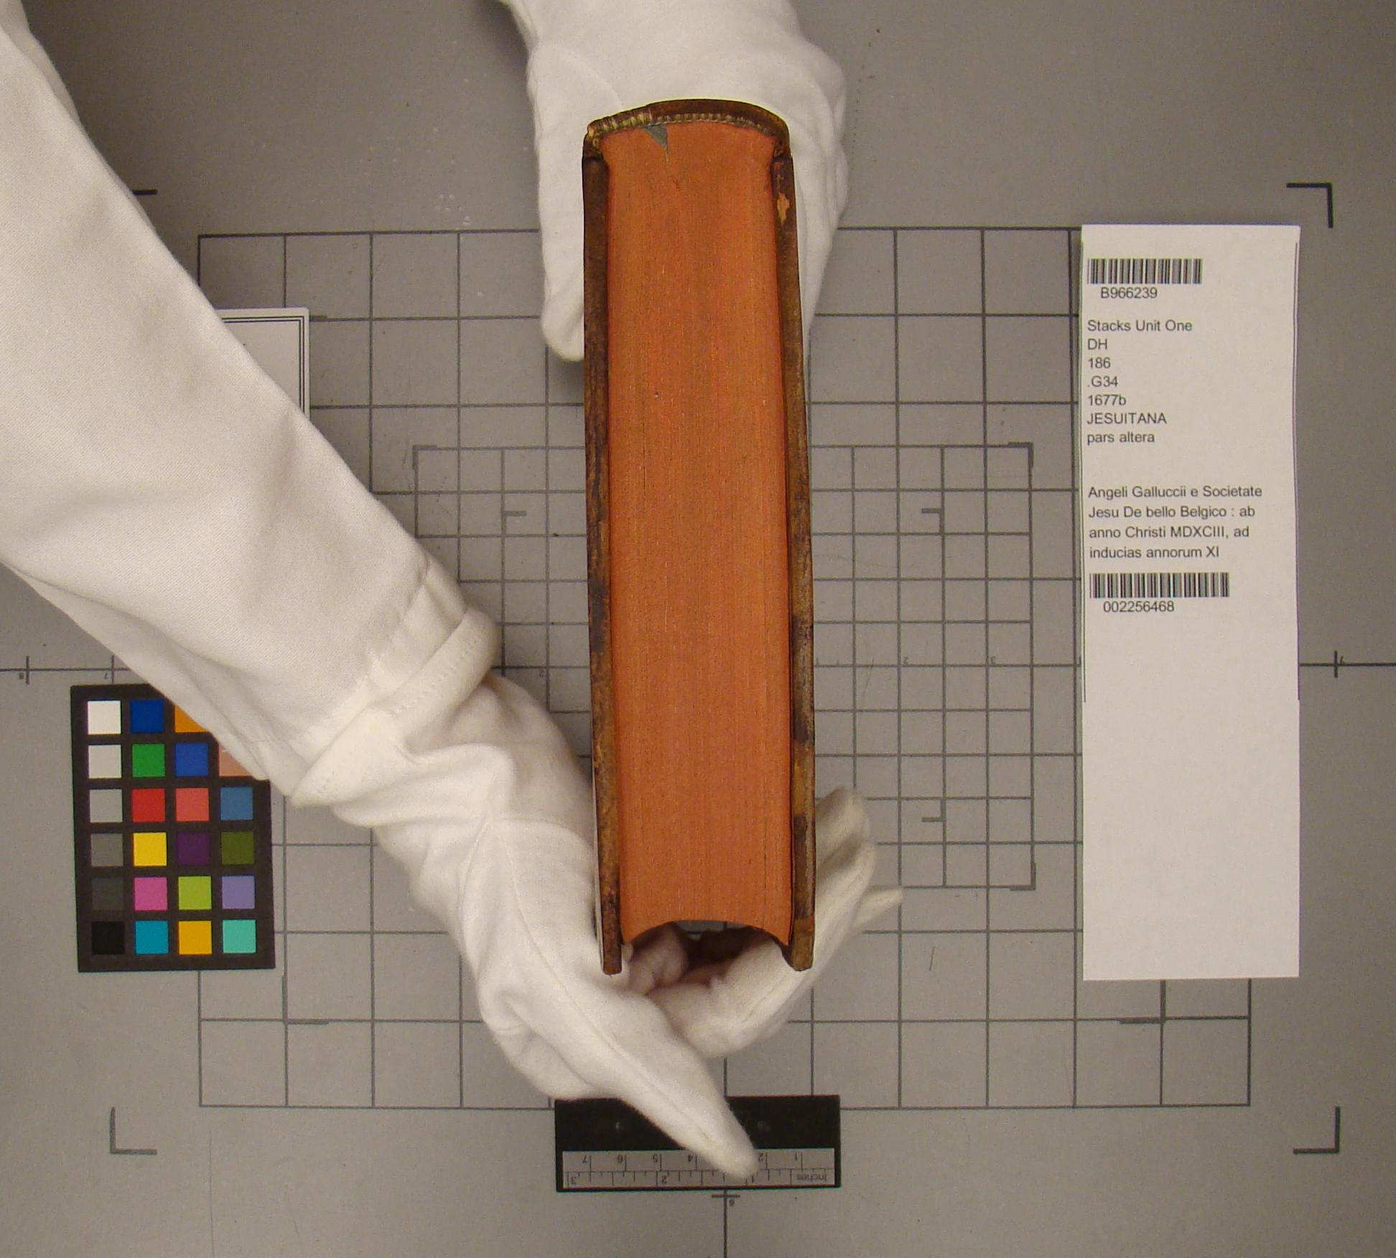

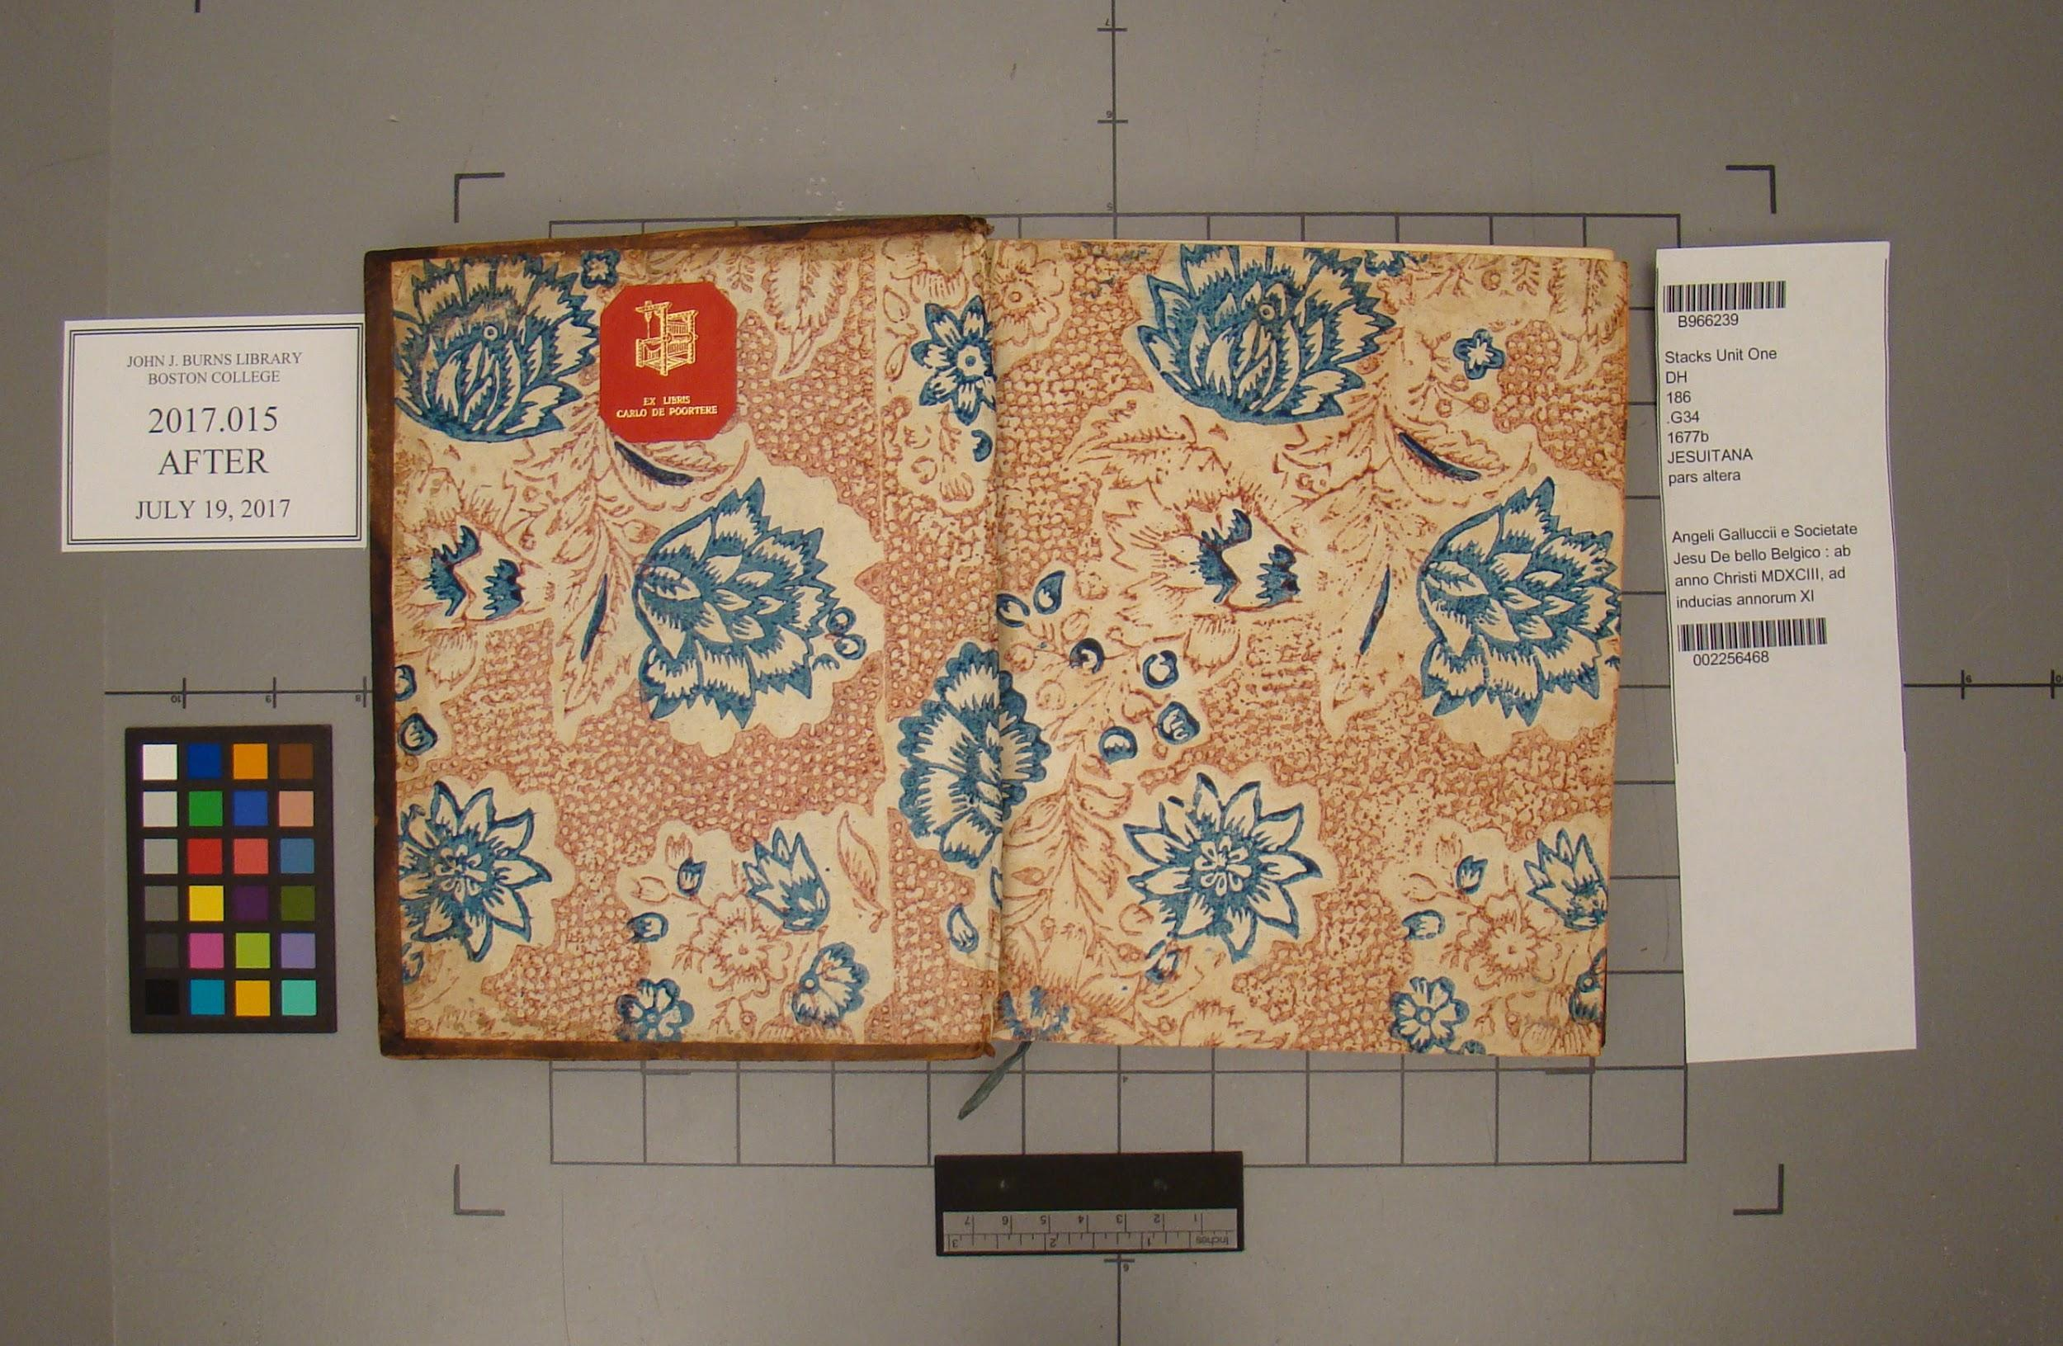

**Ephemera** N/A